Dong Guan Riotouch Technology Co.,Ltd

Riotouch Umind

User Manual

Contents
1. Overview 6
2. Menu 6
2.1 Open 6
2.2 Save 7
2.3 Export 7
2.4 Settings 8
2.4.1 Palm Erase 8
2.4.2 Custom threshold 8
2.4.3 Dark Mode 9
2.4.4 Translation Settings 9
2.5 About 10
2.6 Exit 10
3. QR code 11
3.1 Share the current page 11
3.2 Share all pages 11
4. Plugins 11
4.1 Courseware 11
4.1.1 Account Switching 12
4.1.2 Courseware loading and switching 12
4.1.3 Courseware Demonstration 12
4.2 PHET 14
4.3 Periodic Table 14
4.4Video/web plugin 14
5. Single finger/multi-finger 15
5.1 Single Finger 15
5.2 Multi-finger 15
6. Undo/Redo 16
6.1 Revocation 16
6.2 Recovery 16
7. Eraser 16
7.1 Eraser 16
7.2 Erase Selection 16
7.3 One-click screen clearing 16
8. Pen 17
8.1 Brush Color Settings 17
8.2 Brush Style Settings 17
8.3 Stroke Threshold Setting 18
8.4 Stroke size and transparency settings 19
9. Select 19
10. Insert 20
10.1 Inserting a Chart 20
10.2 Inserting Files 21
10.3 Inserting signal source 21
10.4 History 21
11. Toggle Toolbar 22
12. New 22
13. Screenshot 22
13.1 Screenshots 22
13.2 Application Screenshots 23
14. Camera 23
15. Subject Tools 23
15.1 Ruler 23
15.2 Set square 23
15.3 Protractor 24
15.4 Calendar 24
15.5 Calculator 24
15.6 Timer 25
15.7 Stopwatch 25
15.8 Spotlight 26
15.9 Multiple Screens 26
15.10 Voting 27
15.11 Notes 28
15.12 History 28
16. Page Turning 29
17. Background Image 29
17.1 Color Background 29
17.2 Shape Background 29
17.3 Image Background 29
17.4 Upload background from mobile phone 29
18. Page List 30
18.1 Vertical Preview 30
18.2 Horizontal Preview 30
18.3 Deletion 30

1. Overview
Umind whiteboard software is a special teaching software for interactive electronic whiteboards. It is easy to operate, has smooth writing and powerful functions. Teachers can use this software in lesson preparation and teaching to easily make courseware for various teaching subjects and conduct real-time classroom teaching. The whiteboard software interface is shown in the figure below.
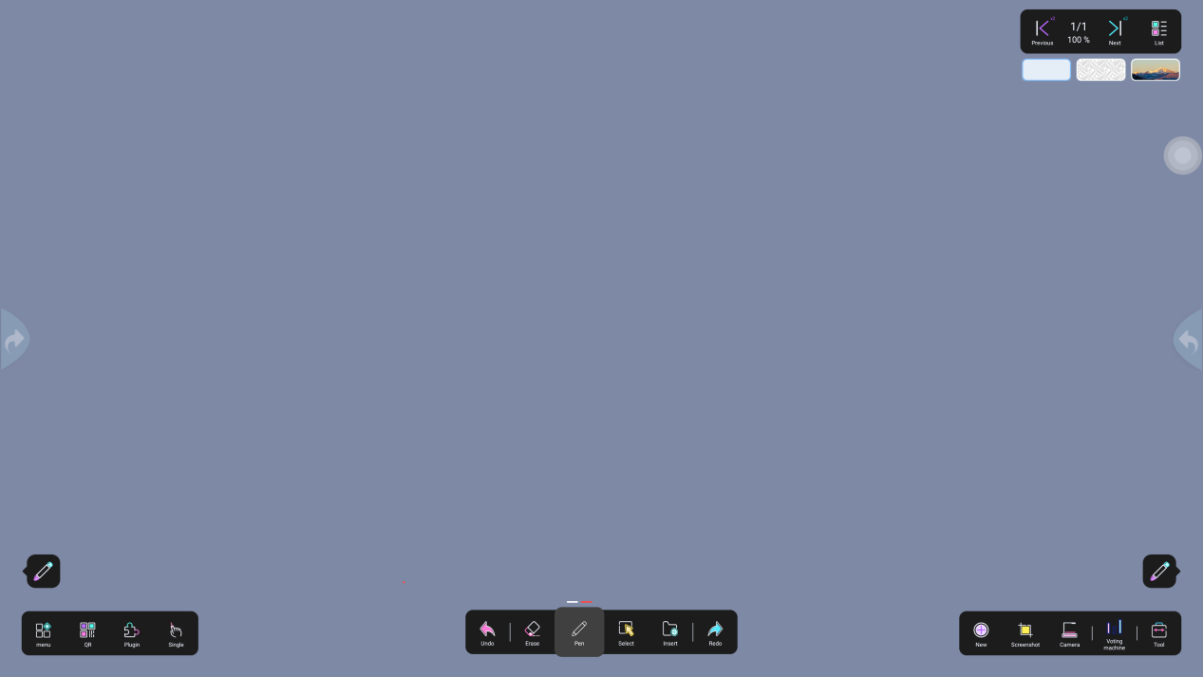

2. Menu

2.1 Open
Click "Open" to jump to the default storage path. You can choose file management or USB drive to open the saved .DZD document, as shown in Figure 1-1
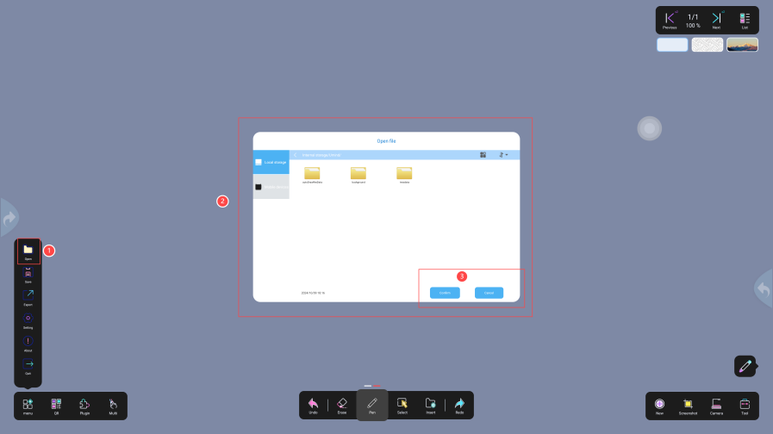

Figure 1-1

2.2 Save
Click the "Save" button to save to the file management or USB drive specified path. By default, it is saved to local storage, as shown in Figure 1-2
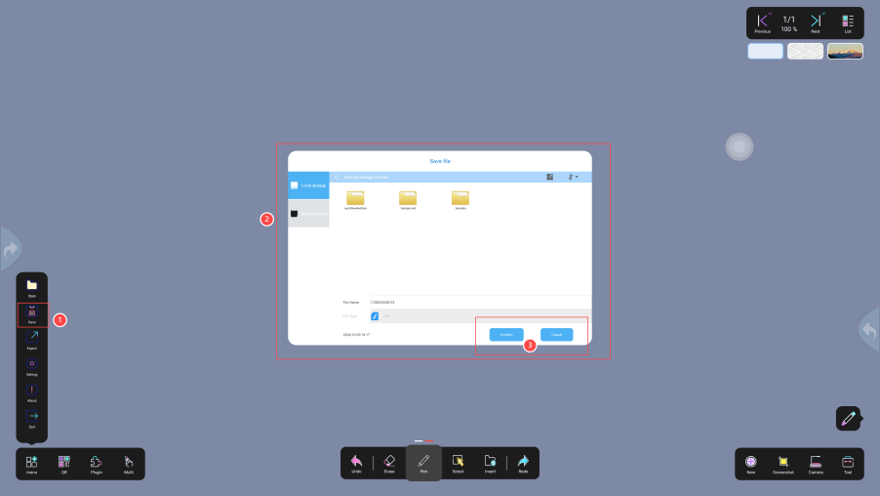
Figure 1-2

2.3 Export
Click "Export" to save in image format. You can only export the current page, while PDF can export all pages, as shown in Figure 1-3.
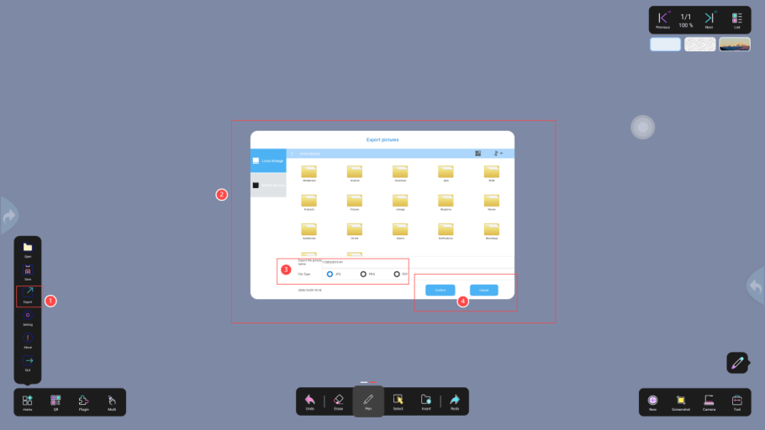
Figure 1-3

2.4 Settings

2.4.1 Palm Erase
Click ①Settings , select ②Turn on/off palm erasure, and use the palm of your hand on the whiteboard to reach the threshold, and the erase shortcut gesture will be enabled, as shown in Figure 1-4
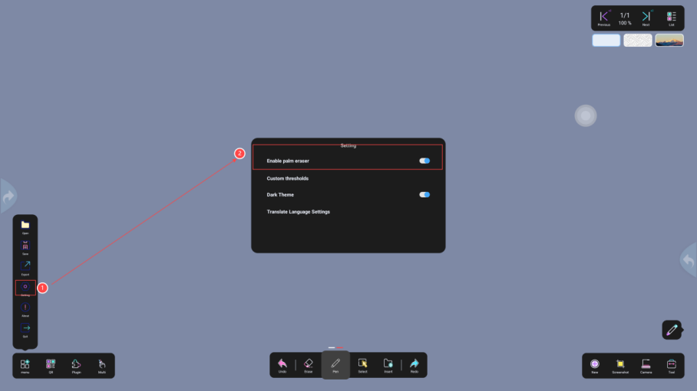
Figure 1-4

2.4.2 Custom threshold
Click ① Settings, select the eraser/thin pen/thick pen mode, click ② "Detect", place your hand or pen in the threshold detection area ③ , click ④ Single "Confirm", click ⑤ Global "Confirm"; the application is successful, as shown in Figure 1-5
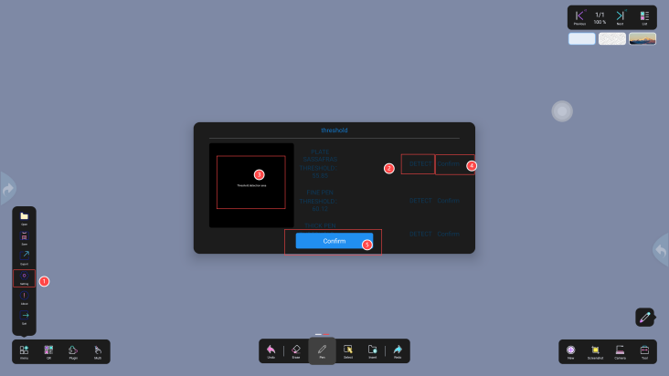
Figure 1-5

2.4.3 Dark Mode
Click ①Settings , select ②Dark Mode, and click the “Switch” button to switch the color (dark by default), as shown in Figure 1-6
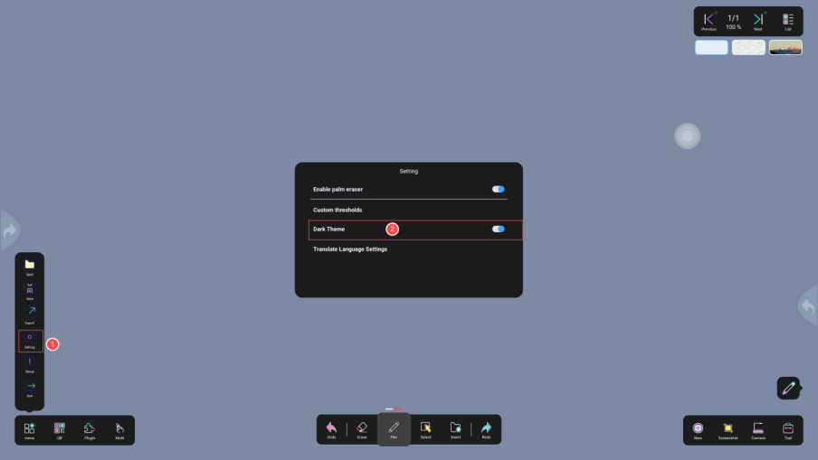
Figure 1-6

2.4.4 Translation Settings
Click ①Settings , select ②Language Translation, ③Select the detected language on the left, and the translation language on the right; enter text on the left to translate, as shown in Figure 1-7
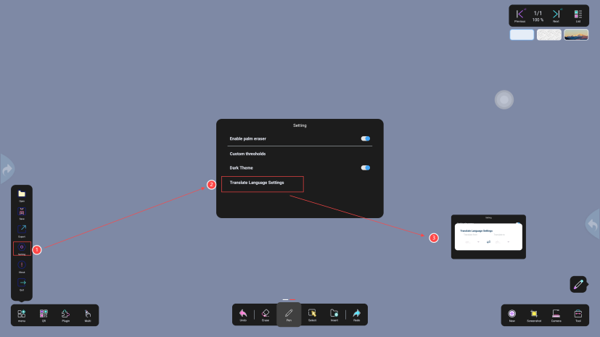
Figure 1-7

2.5 About
Click ① "About", and ② the Umind version number will pop up, as shown in Figure 1-8
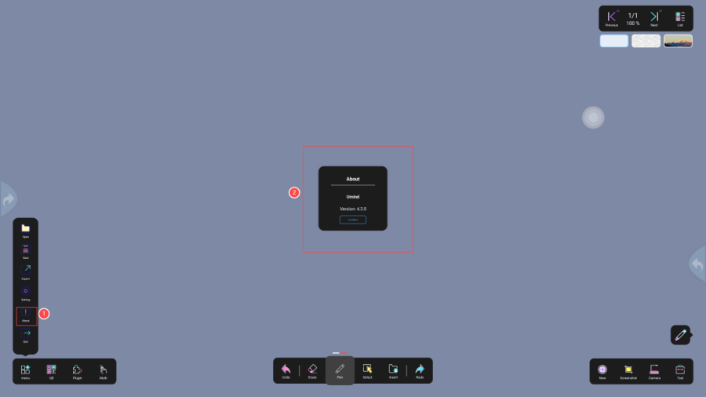
Figure 1-8

2.6 Exit
Click ① "Exit" and ② confirmation window will pop up. You can choose ③ "Save" to exit or directly "Exit", as shown in Figure 1-9
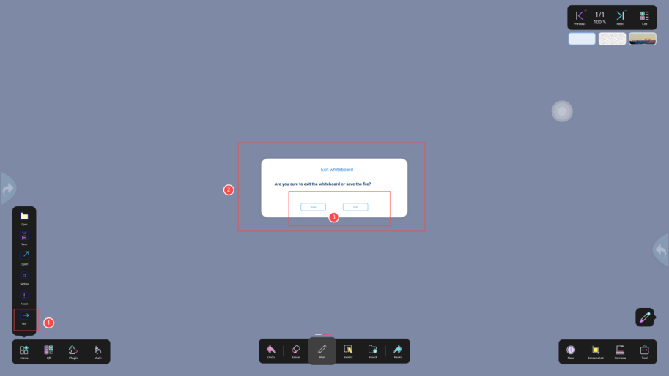
Figure 1-9

3. QR code

3.1 Share the current page
Click "Share current page" and a QR code will pop up. Scan the code with your mobile phone to take away the whiteboard data on the current page, as shown in Figure 1-10

3.2 Share all pages
Click "Share All Pages" and a QR code will pop up. Scan the code with your mobile phone to take away all the whiteboard data, as shown in Figure 1-10
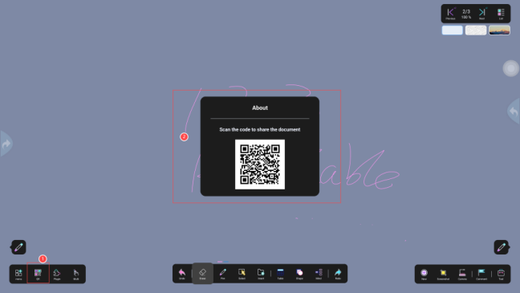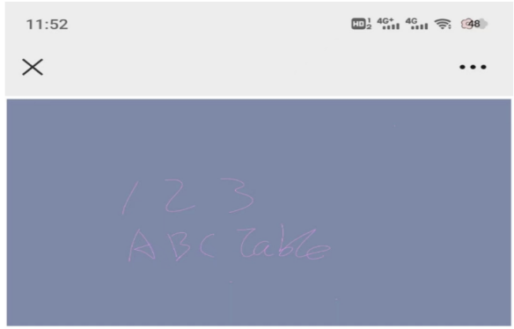
Figure 1-10

4. Plugins

4.1 Courseware

4.1.1 Account Switching
Click the "Switch" icon and scan the courseware with your mobile phone, as shown in Figure 2-1
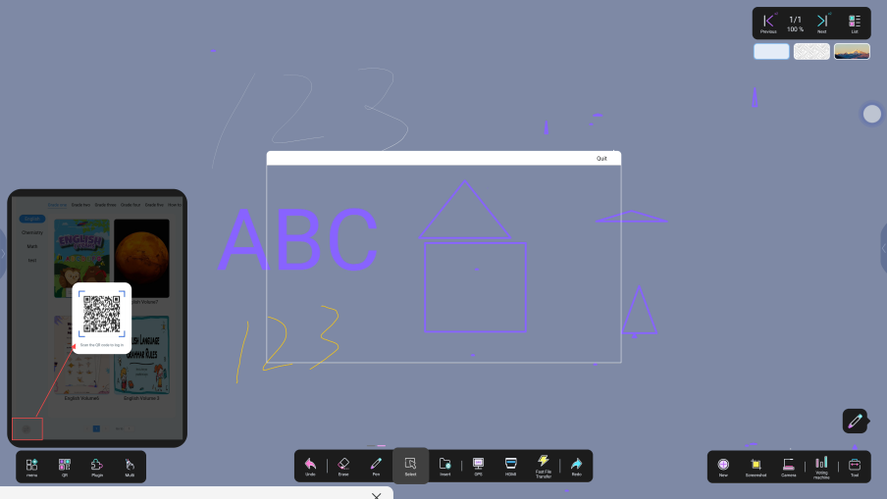
Figure 2-1

4.1.2 Courseware loading and switching
Click on the subject and grade to load the courseware in the directory; click on any courseware to switch courses; as shown in Figure 2-2
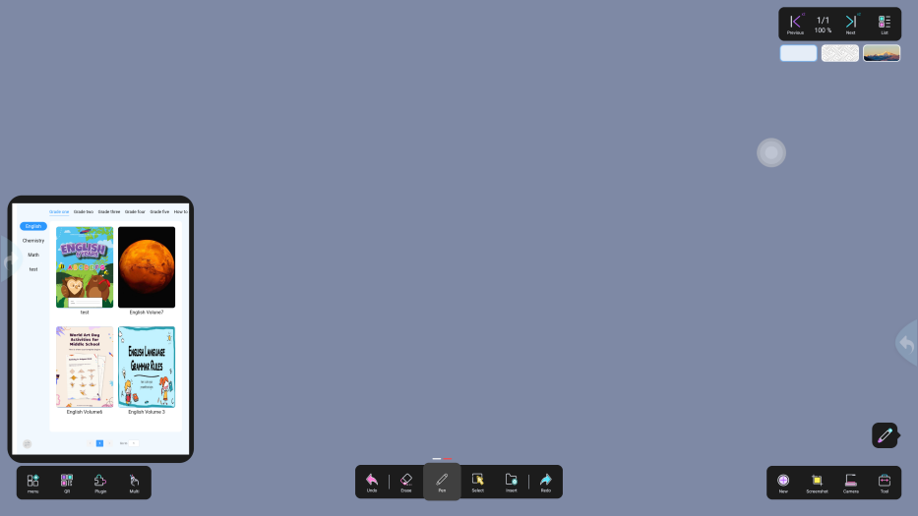
Figure 2-2

4.1.3 Courseware Demonstration
1) Click on any courseware to switch between courses, turn the courseware page to jump to the specified page, and play hot zone events;
2) Sidebar Button
Click ① the "eye" icon to show/hide the hotspot;
Click ② the "Video" icon to trigger the preset video, which can be paused, played, fast forward, rewind, and drag the progress bar;
Click ③ the "Picture" icon to trigger the preset picture and drag it;
Click ④ the "Audio" icon to trigger the preset audio, which can be paused, played, or dragged to progress the progress bar;
Click ⑤ the "Link" icon to jump to the link URL;
Click the ⑥ "Question" icon to trigger the preset question. Click Start and a QR code will pop up. Students can scan the code to answer the question.
Click ⑦ "End Questioning" to check the answer rate, and click the exit button to exit the question page
shown in Figure 2-3
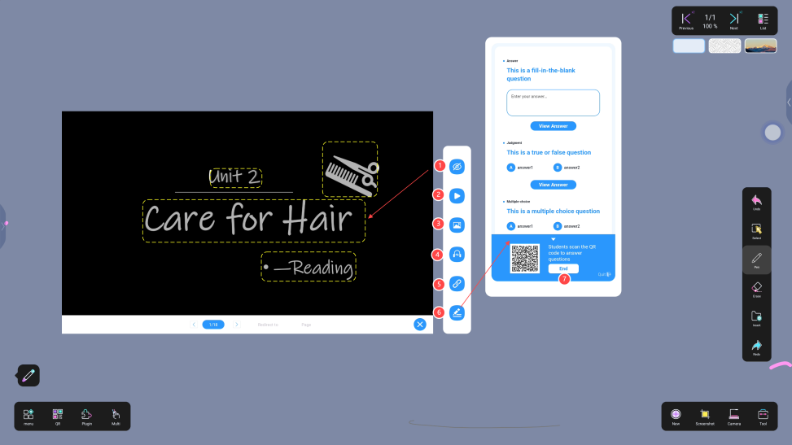
Figure 2-3

4.2 PHET
Open PHET and enter the interactive animation simulation teaching material, as shown in Figure 2-4
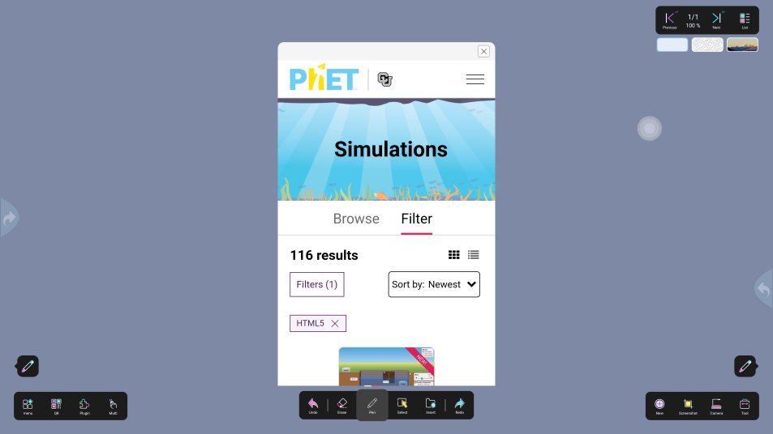
Figure 2-4

4.3 Periodic Table
Open the periodic table and click on a chemical element to display the element animation, as shown in Figure 2-5.
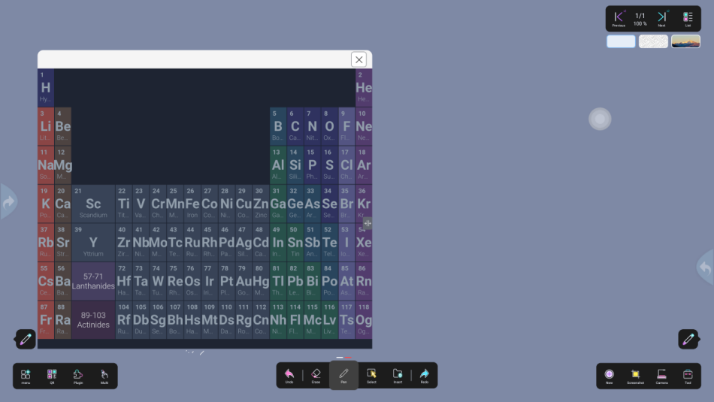
Figure 2-5

4.4Video/web plugin
When the courseware needs to open courseware elements such as pictures, videos, audio, links, etc., you need to download the plug-in first to play the courseware elements, as shown in Figure 2-6
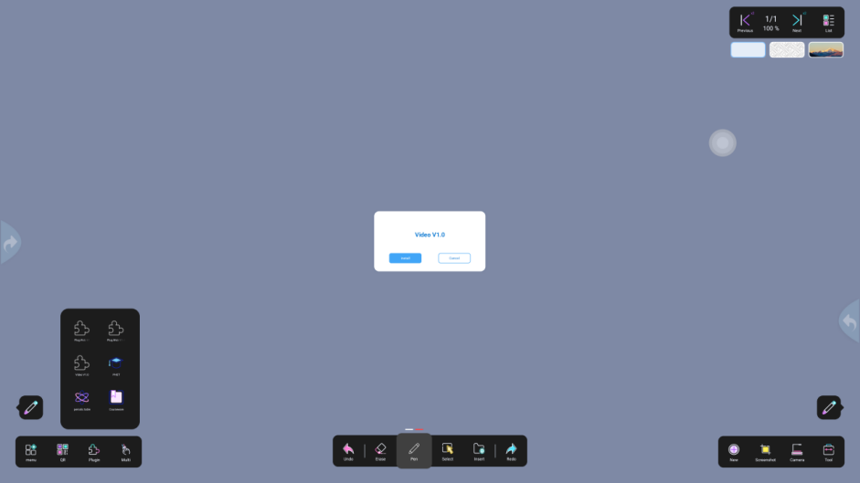
Figure 2-6

5. Single finger/multi-finger

5.1 Single Finger
In single-finger mode, only one-point touch writing is supported. Two or more fingers can be placed on the whiteboard page to move or zoom. The page percentage is displayed in the upper right corner, as shown in Figure 2-7.

5.2 Multi-finger
The multi-finger mode supports multiple people to write collaboratively at the same time, with 20 touch points by default, as shown in Figure 2-7
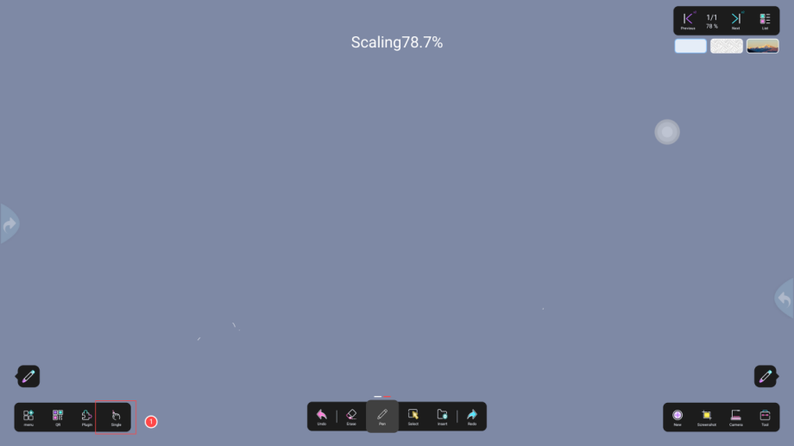
Figure 2-7

6. Undo/Redo

6.1 Revocation
Click ① to withdraw the previous operation, as shown in Figure 2-8

6.2 Recovery
Click ② to resume the next step, as shown in Figure 2-8
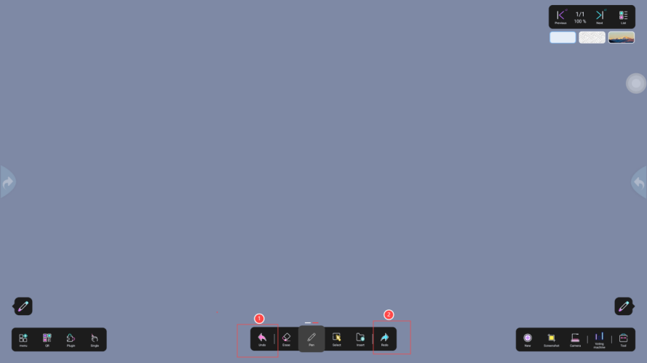
Figure 2-8

7. Eraser

7.1 Eraser
Click ① In this mode, place your hand on the whiteboard and an eraser icon will appear. Slide to erase, as shown in Figure 2-9

7.2 Erase Selection
Click ②In this mode, you need to select the object to erase, as shown in Figure 2-9

7.3 One-click screen clearing
Click ③ and slide from left to right to clear the screen, as shown in Figure 2-9
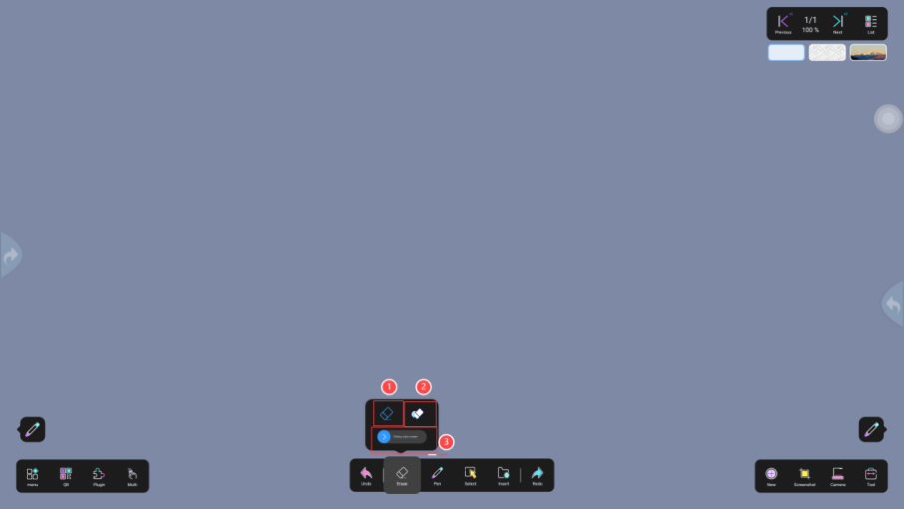
Figure 2-9

8. Pen
This pen is a double-headed pen, the left one is a "fine pen" and the right one is a "bold pen". You need to select them first before adjusting the color (the pressure-sensitive pen supports dual-color pen heads)

8.1 Brush Color Settings
The default 12 colors or a custom color palette can be used to switch the brush color (select ① thin/thick pen and click ② color switch), as shown in Figure 2-10
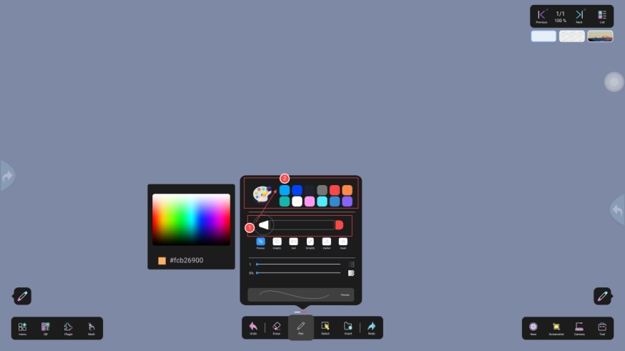
Figure 2-10

8.2 Brush Style Settings
Pressure-sensitive pen: The thickness changes according to the writing force. The effect is shown in the following figure①
Graphic pen: recognizes hand-drawn graphics into regular shapes (circles, triangles, squares, rectangles). The effect is shown in the following figure②
AI smart pen: Handwritten characters are intelligently recognized as printed characters, as shown in Figure ③
Stick drawing: Graffiti is automatically recognized, and the corresponding stick drawing effect is selected according to the needs as shown in the following figure ④
Marker: Select the marker style, set the stroke size, color, and transparency. The effect is shown in the following figure⑤
As shown in Figure 3-1
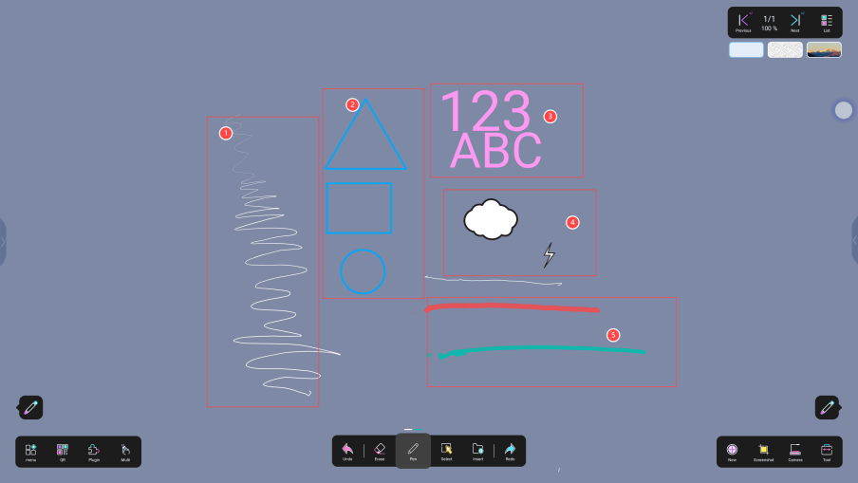
Figure 3-1

8.3 Stroke Threshold Setting
Place the pen in thin pen ① and thick pen ② respectively , and the pen stroke size will be automatically detected, as shown in Figure 3-2
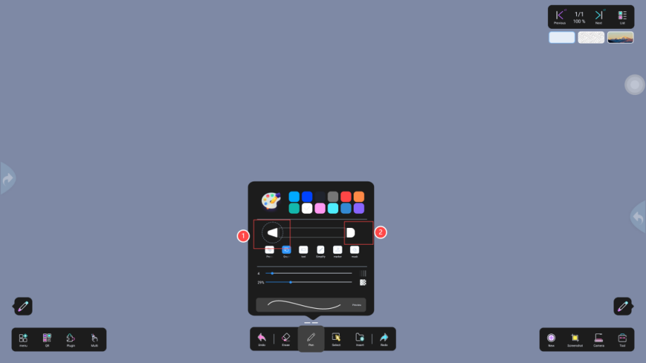
Figure 3-2

8.4 Stroke size and transparency settings
Click ① to set the pen size. Slide from right to left to reduce the pen size, and slide from left to right to increase the pen size (the minimum is 1 and the maximum is 40). The thickness of the pen can be seen in the preview interface; click ② to set the writing transparency. Slide from right to left to reduce the transparency percentage, and slide from left to right to increase the transparency percentage; as shown in Figure 3-3
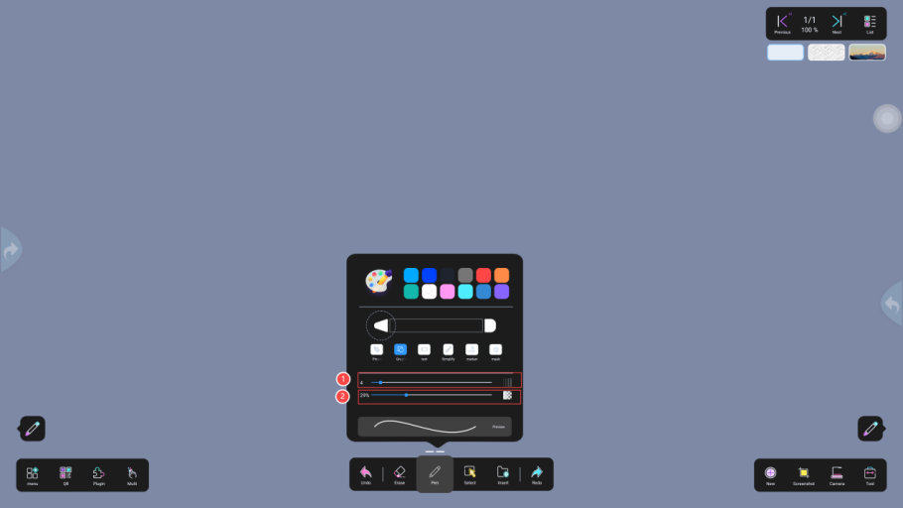
Figure 3-3

9. Select
Click the Select button. After selecting the object, a dotted frame will appear outside the frame, and you can copy, move, or delete it.
Example 1: Click Select and select the selected area. You can adjust the font size, switch colors, copy, delete, and search, as shown in Figure 3-4.
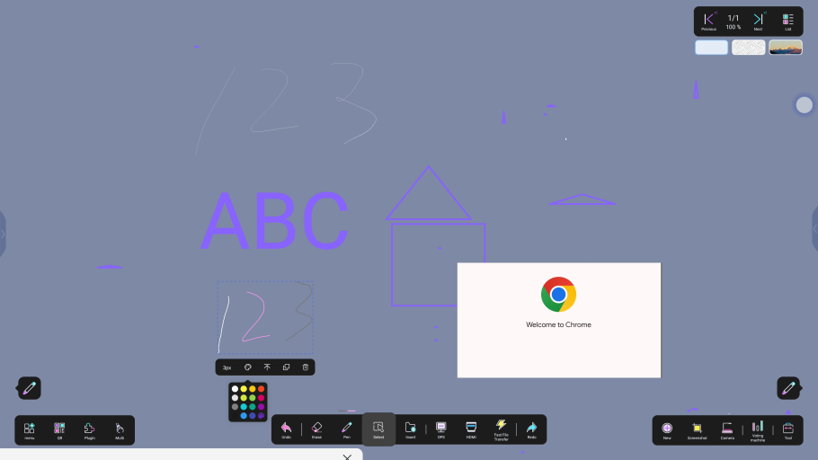
Figure 3-4
Example 2: For the screenshot selection, you can perform text recognition, adjust layers, copy, delete, and search functions, as shown in Figure 3-5
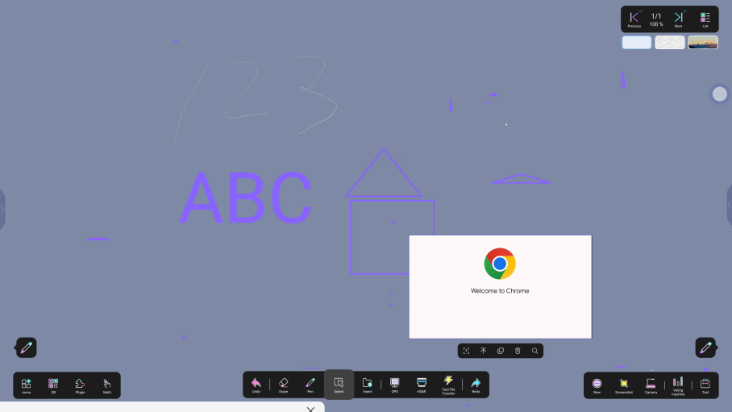
Figure 3-5

10. Insert

10.1 Inserting a Chart
Click Insert Chart to select a table, graph, or mind map. The effect is as shown in Figure 3-6.
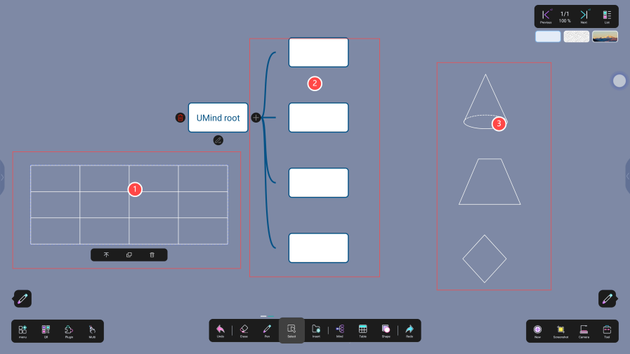
Figure 3-6

10.2 Inserting Files
Click Insert File, select the type of image/video/document you want to insert, and the import is successful. For example, insert an image, as shown in Figure 3-7
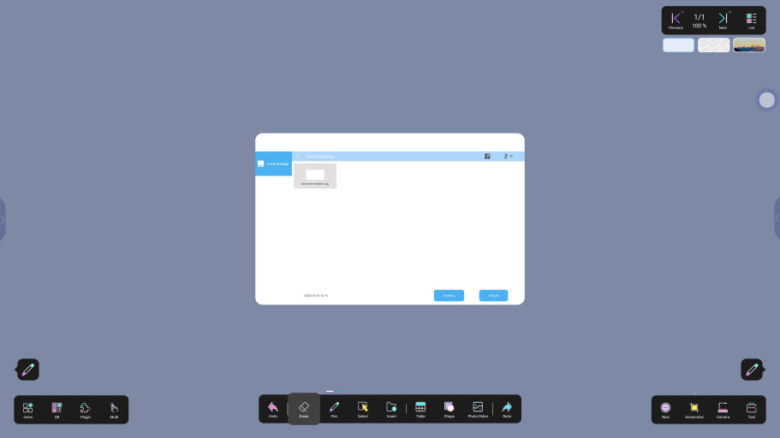
Figure 3-7

10.3 Inserting signal source
Click the signal source to insert OPS, HDMI, and fast transfer to switch normally

10.4 History
The used charts are recorded on the right side of Insert. You can directly select the corresponding chart in the history, as shown in Figure 3-8
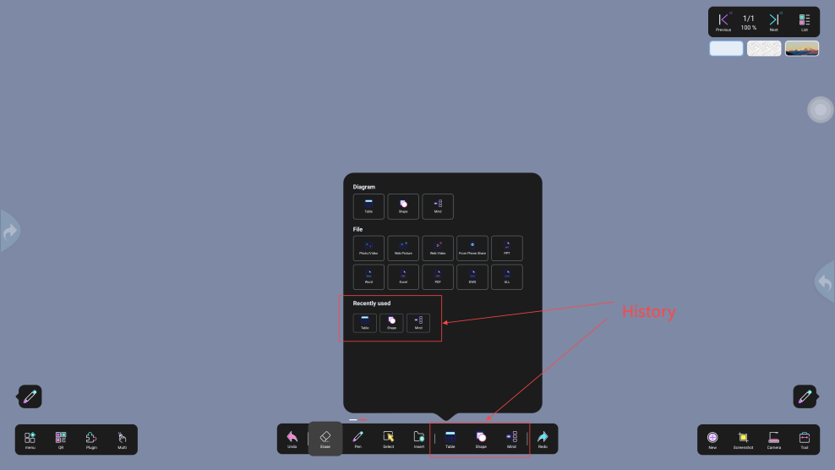
Figure 3-8

11. Toggle Toolbar
Click ①② to switch to the two-side display, as shown in Figure 3-9
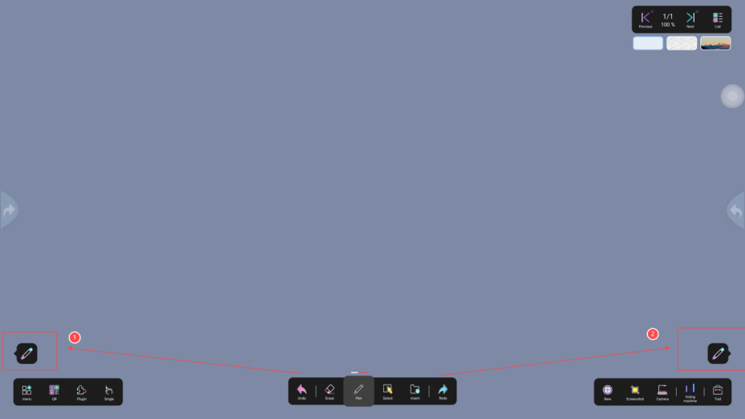
Figure 3-9

12. New
Click "+" to create a new page, list page +1, the number of pages in the upper right corner +1

13. Screenshot

13.1 Screenshots
Click the "Screenshot" icon to capture any picture, which will be saved to local storage by default, as shown in Figure 3-10
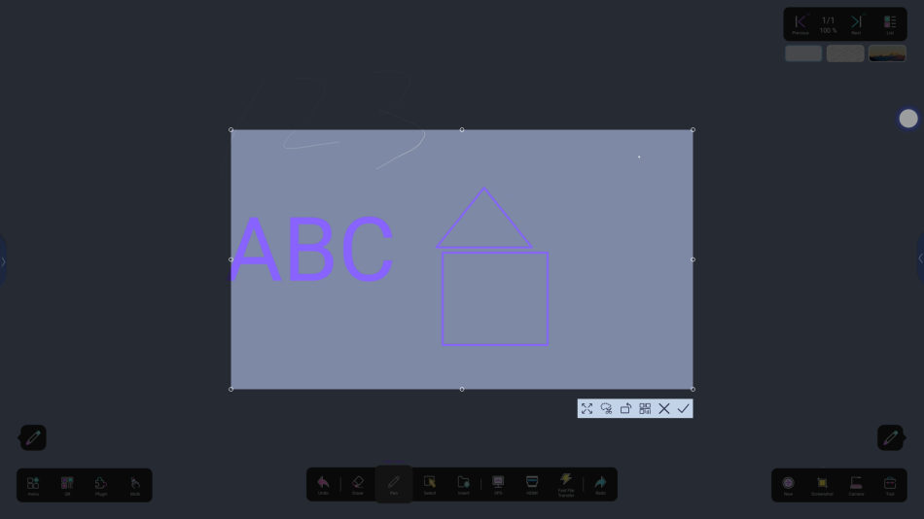
Figure 3-10

13.2 Application Screenshots
Click the "App Screenshot" icon, select an app, and take any screenshot. By default, it will be saved to local storage, as shown in Figure 4-1.
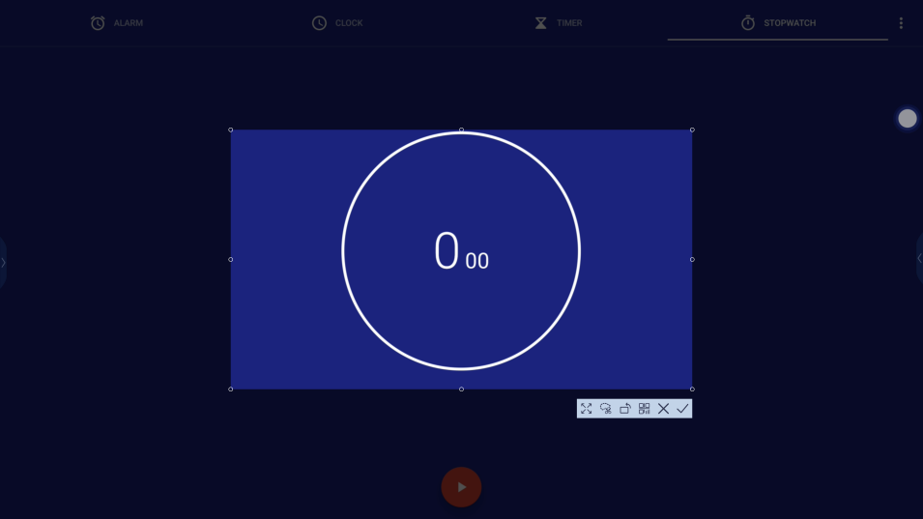
Figure 4-1

14. Camera
Click "Camera" to take photos and record videos.

15. Subject Tools

15.1 Ruler
Click the ruler to rotate, close, measure, etc., as shown in Figure 4-2

15.2 Set square
Click the set square to rotate, close, and measure the angle, as shown in Figure 4-2.

15.3 Protractor
Click the protractor and press and hold the rotation button, check button, and cross button to close the protractor, as shown in Figure 4-2
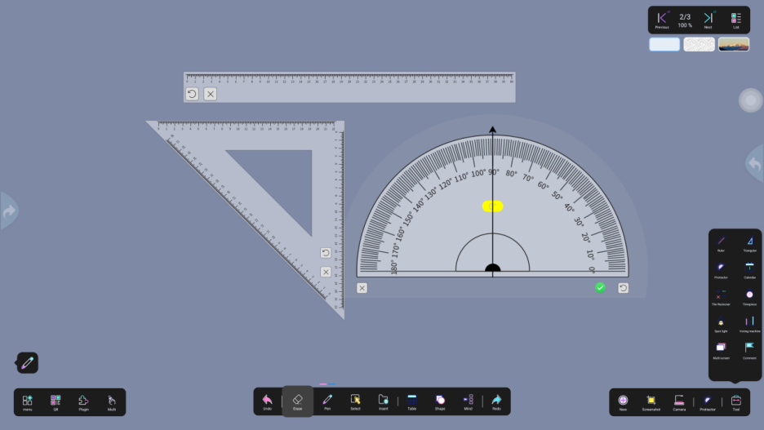
Figure 4-2

15.4 Calendar
Click the calendar to view the current date, and scroll up and down to view the date, as shown in Figure 4-3
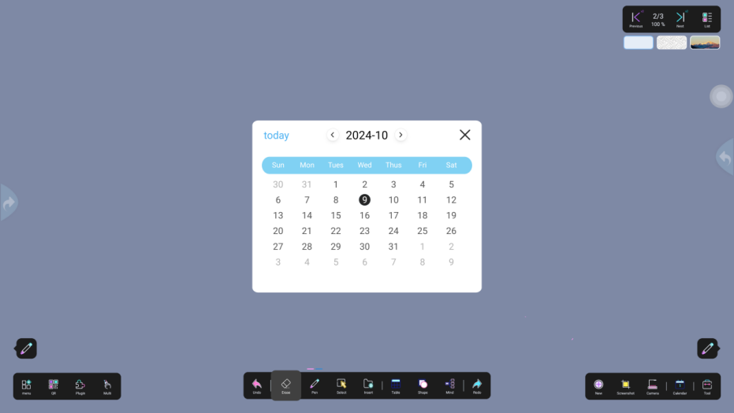
Figure 4-3

15.5 Calculator
Click the calculator to perform common addition, subtraction, multiplication and division operations, as shown in Figure 4-4.
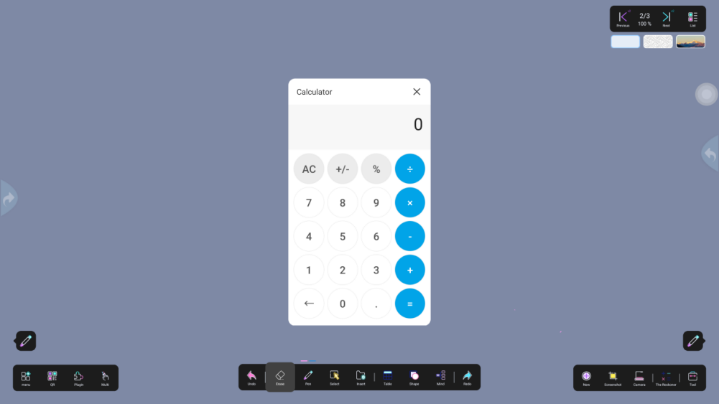
Figure 4-4

15.6 Timer
Set countdown time > Start/stop countdown; when the countdown reaches 3 seconds, there will be a sound reminder, as shown in Figure 4-5
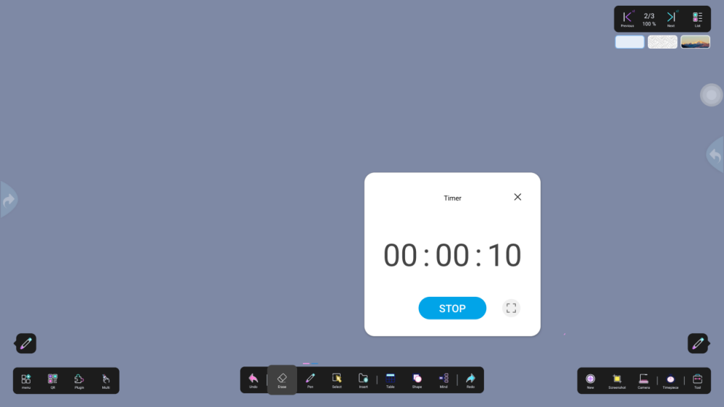
Figure 4-5

15.7 Stopwatch
Open the stopwatch > click the stop icon, pause the timing > click the icon to clear the timing; switch to full screen, tap to restore the small window, as shown in Figure 4-6
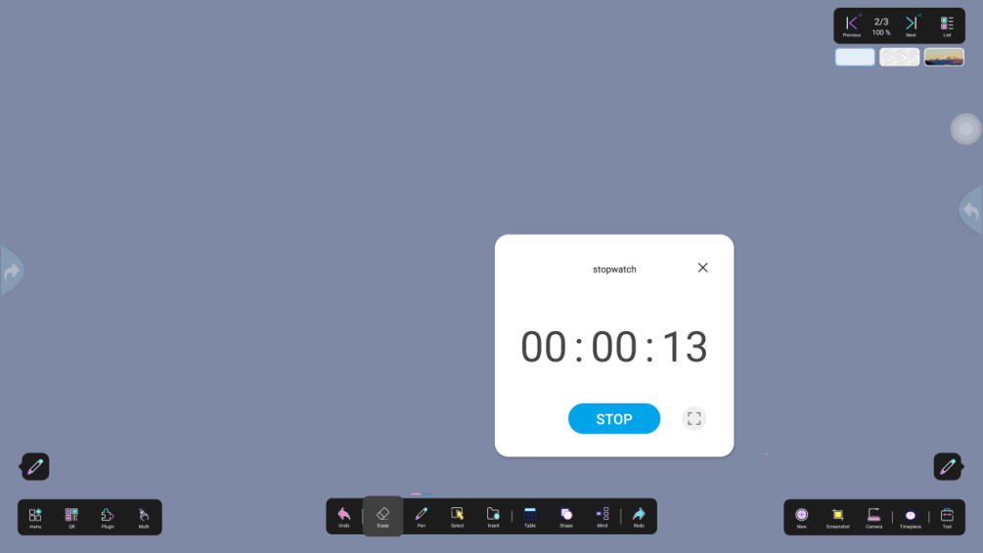
Figure 4-6

15.8 Spotlight
Click Spotlight to enter the spotlight effect, click ① to set different spotlight icons such as triangle, circle, square, pentagon; click ② to set the color of the non-spotted area: such as black, red, blue, click + to add any color, drag the progress bar to adjust the spotlight color; place one finger on ③ , pull up to zoom out, pull down to zoom in; click × to turn off the spotlight, as shown in Figure 4-7
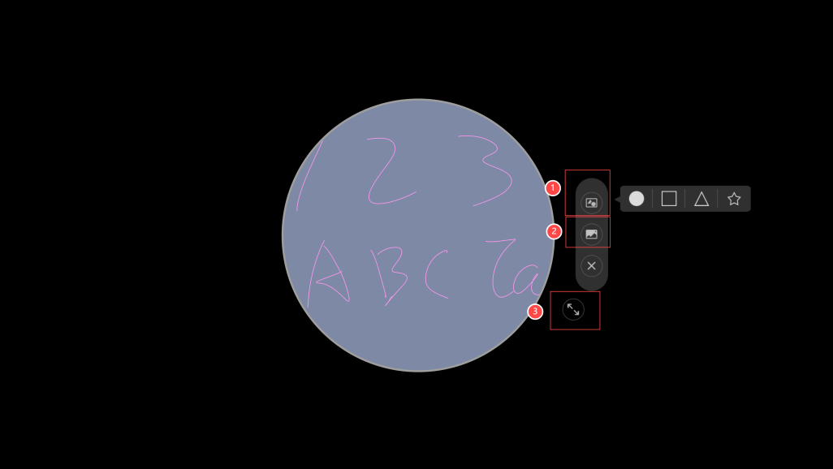
Figure 4-7

15.9 Multiple Screens
Click Multi-screen to set the number of split screens: 2, 3, 4; set the split screen background: white, green, yellow, black; click to confirm the application is successful, click Cancel to cancel the multi-screen application; the default number of split screens is 2, and the default color is white; as shown in Figure 4-8
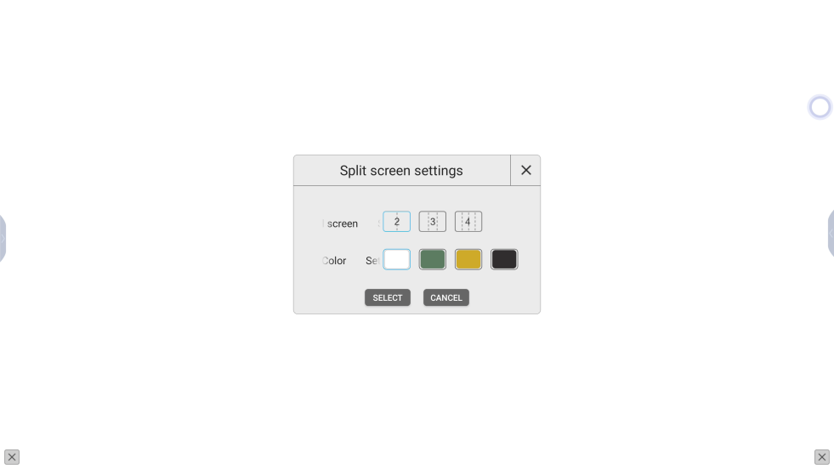
Figure 4-8

15.10 Voting
The creator ① scans the QR code with his mobile phone, ② creates a vote, as shown in Figure 4-9
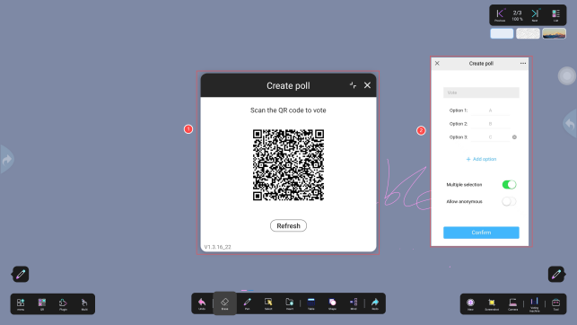
Figure 4-9
Voters ① scan the QR code with their mobile phones, ② cast their votes, as shown in Figure 4-10
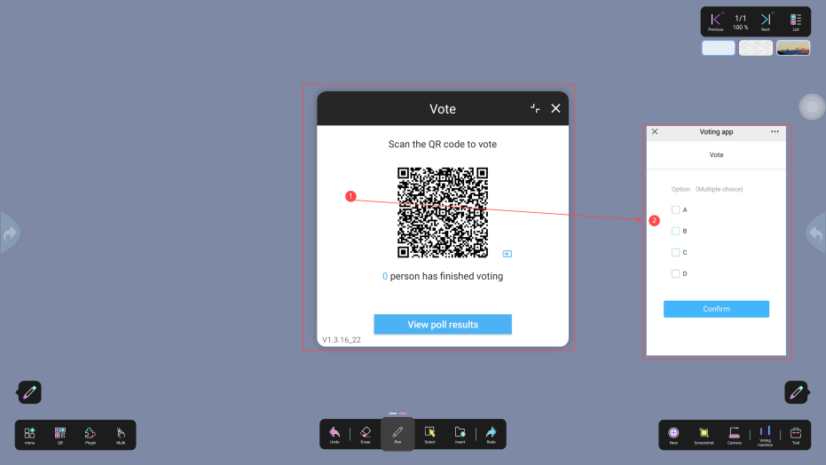
Figure 4-10

15.11 Notes
Open the annotation for editing, click ① to switch colors and set the size; ② to withdraw and restore; ③ to erase the annotation content and delete it; ④ to save the annotation (save as an image in the default local storage or scan the QR code to save); Note: You need to close the annotation to operate the whiteboard toolbar function, as shown in Figure 5-1
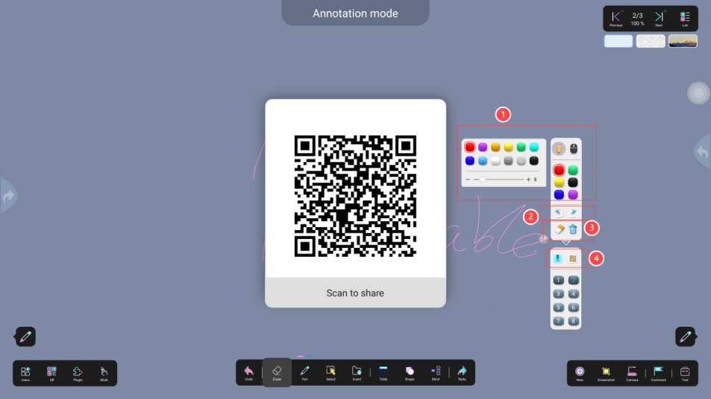
Figure 5-1

15.12 History
The tools used will be recorded on the left side of the subject tool

16. Page Turning
Support up and down buttons to turn pages or slide the list to select pages

17. Background Image
Click ① pop-up window ② to set the whiteboard background according to your needs,

17.1 Color Background
Switch the background color in the background color interface (the default color is gray), click OK, and the application is successful, as shown in Figure 5-2

17.2 Shape Background
Switch the background in the background graphics interface, click OK, and the application is successful, as shown in Figure 5-2

17.3 Image Background
Switch the background in the picture interface, click Confirm, and the application is successful; users can select pictures from pictures and the default browser, as shown in Figure 5-3

17.4 Upload background from mobile phone
Scan the image with your mobile phone and upload it, and set the image as the whiteboard background, as shown in Figure 5-2
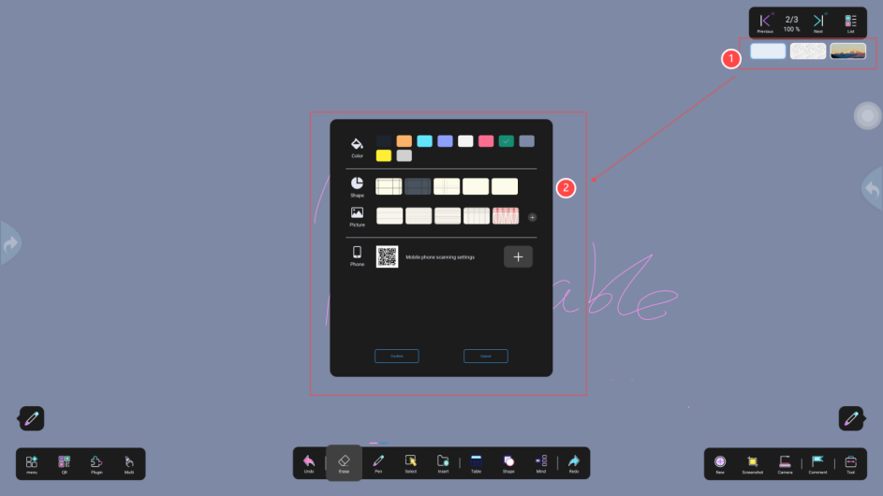
Figure 5-2

18. Page List
Click ① to pop up window ② , you can preview horizontally or vertically, delete pages, etc.

18.1 Vertical Preview
Click the "List" button to enter the page preview. You can slide up and down to view the page, switch to the corresponding page, and the total number of pages and the current page are displayed in the upper right corner, as shown in Figure 5-3

18.2 Horizontal Preview
Click the "Horizontal" icon to preview horizontally, as shown in Figure 5-3

18.3 Deletion
Click "×" to delete a single page, and click the "Delete" icon to delete all other pages, leaving only one page, as shown in Figure 5-3
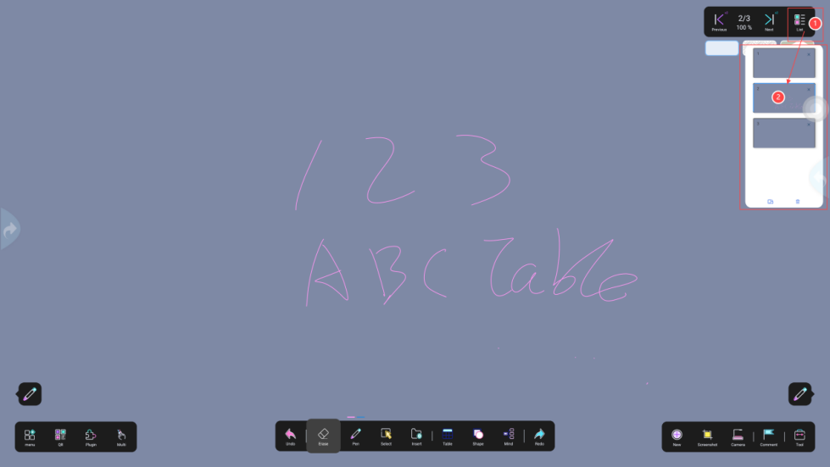
Figure 5-3

