Contents
1. Cloud Platform 2
1. Overview 2
2. Login 2
3. Create subjects and grades 2
3.1 Create Subject 2
3.2 Create Grade 3
4. Add courseware 3
5. Courseware Design 4
5.1 Courseware Preview 4
5.2 Adding Hotspot 4
5.3 Right page information bar 5
6. Courseware editing 7
7. Courseware deletion 8
8. Log out
2. UCourse 9
1. Overview 9
2. Log in to Courseware 9
3. Courseware Demonstration 10
3.1 Preview and page switching 10
3.2 Sidebar Button 11
4. Exit courseware 16

Part 1: Cloud Platform

1. Overview
The cloud platform mainly includes account management, device management, group management, firmware management, resource management and other major contents. This chapter will focus on the specific operations of resource management, which is mainly used for teacher users to prepare lessons .

2. Log in
Enter the URL, enter the username and password, and click Login, as shown in the figure
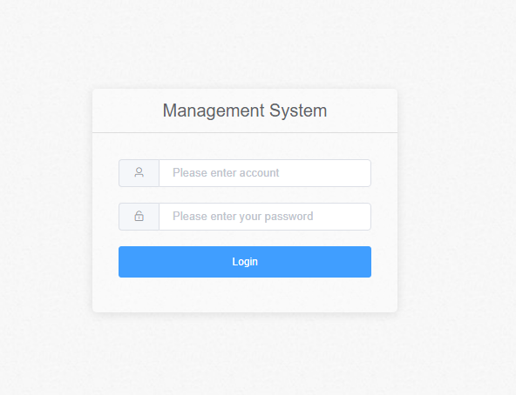

3. Create subjects and grades
Note: This function is not teacher users. If there are no subjects and grades, please contact the school administrator to add subjects and grades . This is a demonstration of the school user function.

3.1 Create subjects
Click ① "Add Subject", a pop-up window ② will pop up , enter "Subject Name", and click the "Submit" button to create a subject, as shown in the figure
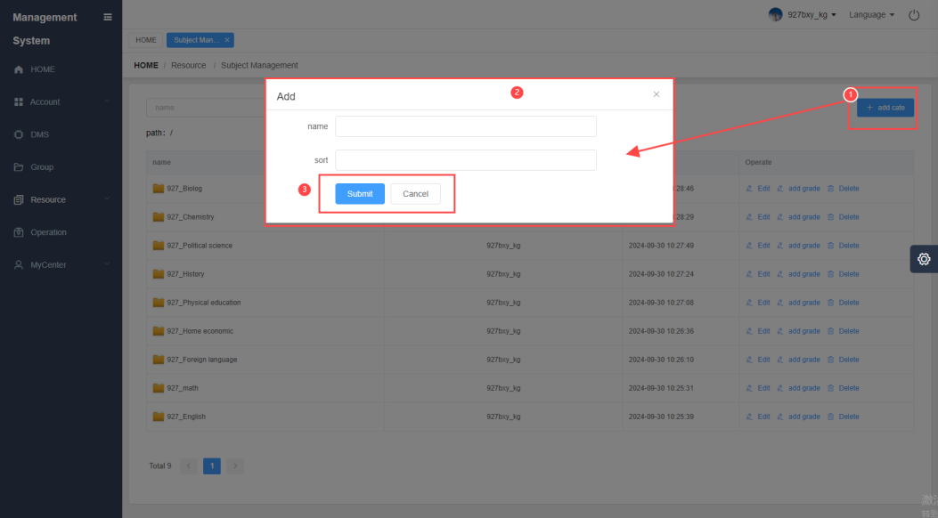

3.2 Create Grade
Click ① "Add Grade", a pop-up window ② will pop up, enter the "Grade Name", and click the "Submit" button to create it. There are two ways to create a grade:
Path 1. On the right side of the Create Subject column, click Add Grade
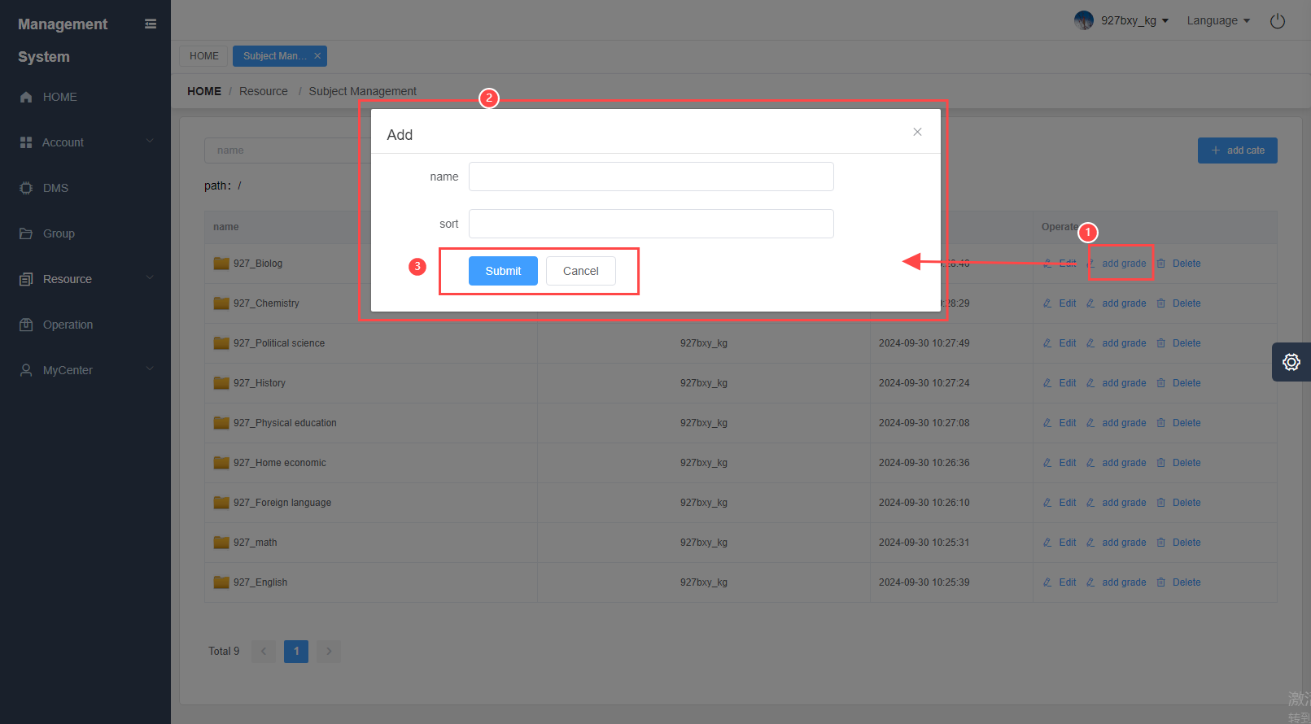

Path 2. Double-click the new subject, enter the directory, and click "Add grade" in the upper right corner
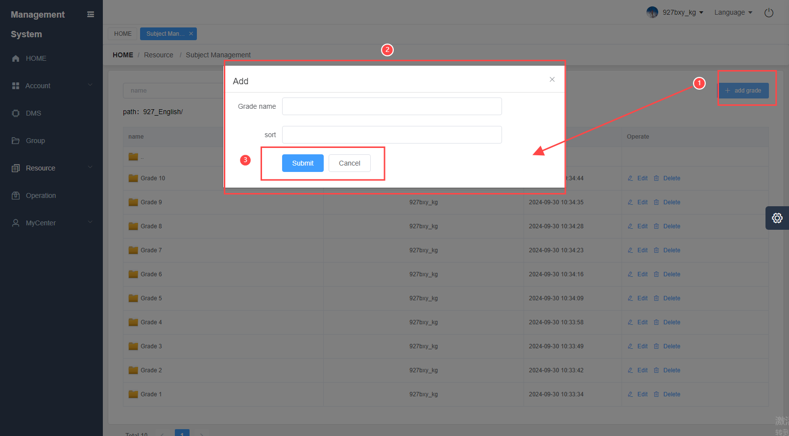

4. Add courseware
Double-click to enter the grade directory under the subject, select the grade to which you need to add courseware, and double-click to enter;
Click ① "Add Courseware" button, ② enter the courseware name, cover image, upload the courseware (currently only supports PDF format), the visibility status is public by default (checking Public Visible means that others can share the resource courseware, checking Private Visible means that only individuals can view and edit the courseware), and finally click the "Generate Courseware" button, as shown in the figure:
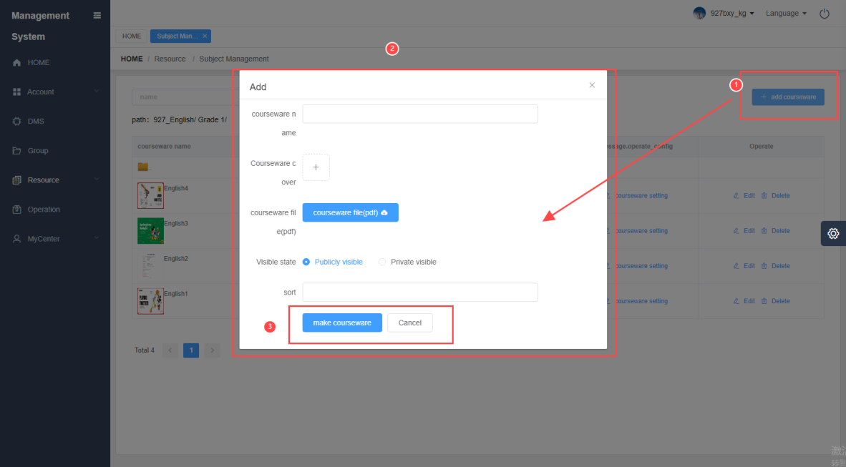

Note: When the file is too large, it will take some time to generate the courseware. Please wait patiently.

5. Courseware Design
This page is the main page of courseware design, as shown in the figure ① Save and exit on the top right, ② The left side is the hotspot adding area, ③ The middle is the courseware view page, ④ The right side is the page information bar, ⑤ The bottom is the courseware preview page
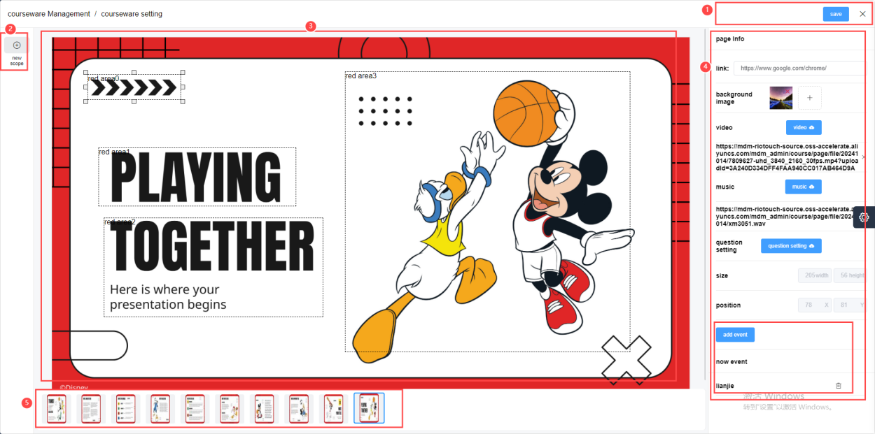

5.1 Courseware Preview
Switch to the courseware preview page at the bottom to edit the current page

5.2 Adding Hotspots
Click ① "Add Hotspot", drag it to the specified position ② , click ③ "Add Event", edit ④ select the event type, including pictures, videos, links, audio, enter the event name and upload resources, and click the "Submit" button; after the hotspot is successfully created, the added name will be displayed in the lower right corner ⑤ , and you can delete it, as shown in the figure
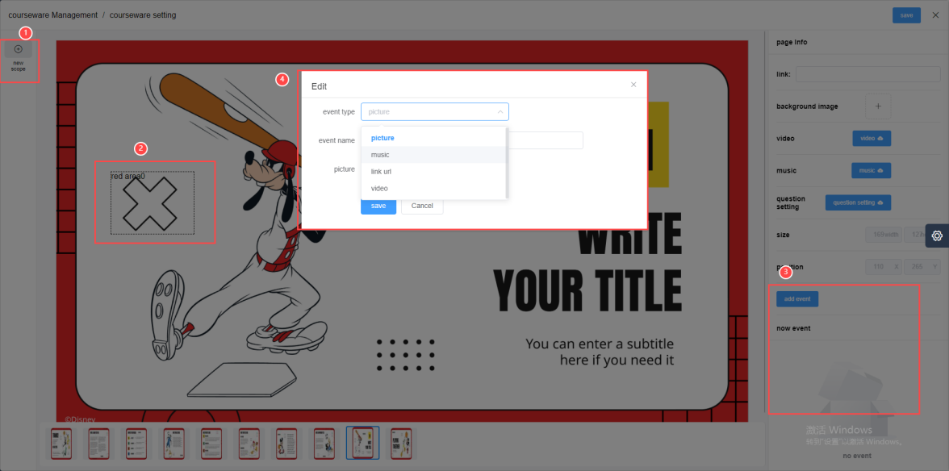

5.3 Right page information bar
- Link: Select the link text box and enter the URL to jump to, as shown in the figure
- Background image: Click "+" to jump to the storage path and select the image you want to upload
- Video: Click the "Video" icon to jump to the storage path and select the video you want to upload
- Audio: Click the "Video" icon to jump to the storage path and select the audio to be uploaded

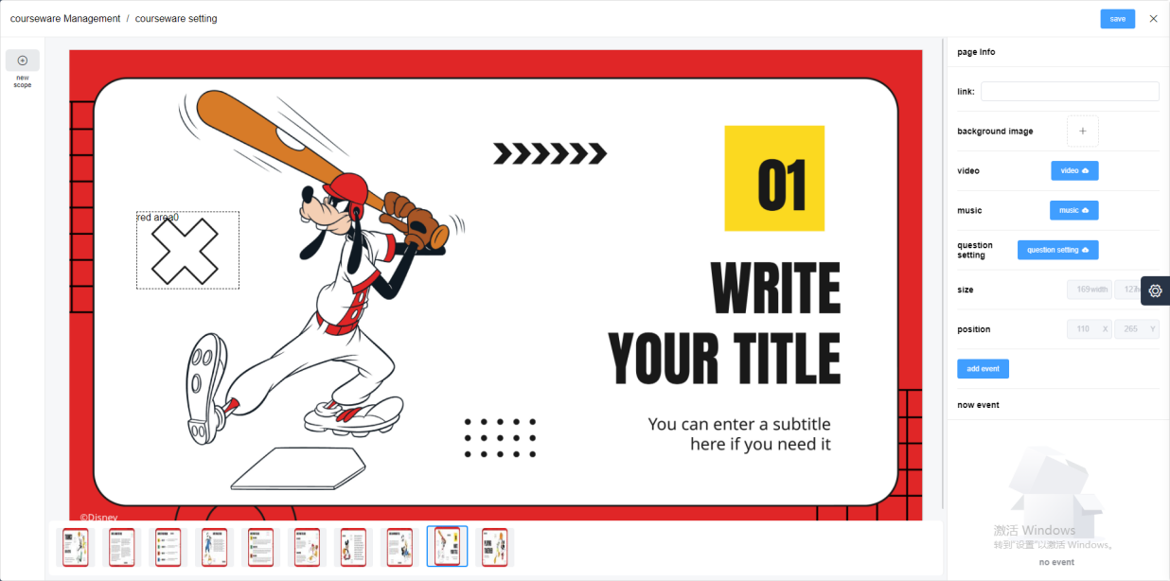

- Topic configuration: mainly for adding topics, publishing topics, removing topics, etc.
- Add a topic
Click "Add Question" > Select Question Type > Enter Question > Enter Answer Options and Check the Correct Answer > Click "Save", as shown in the figure; Users can add and delete answer options based on the number of answers, and the answer options must have at least one option
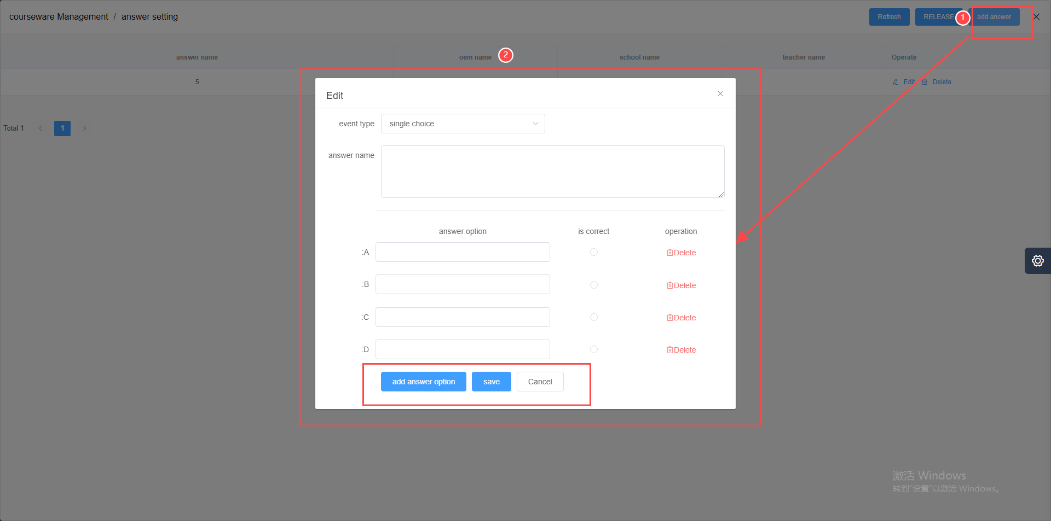

- Post a topic
Click "Publish Topic" as shown in the figure. After the topic is published, the umind client will upload the topic synchronously, and the teacher can perform other operations. For details of the operation, please refer to the UCourse courseware demonstration below
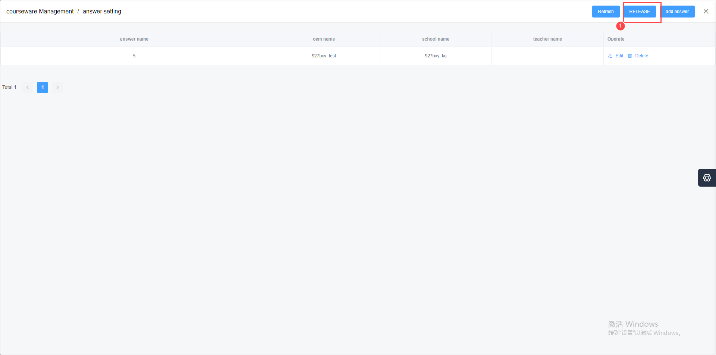

- Removed topic
Click "Remove Question" as shown in the picture. The umind client will remove the question synchronously, and the question QR code will pop up. Teachers can scan the code with their mobile phones to edit and publish the question.
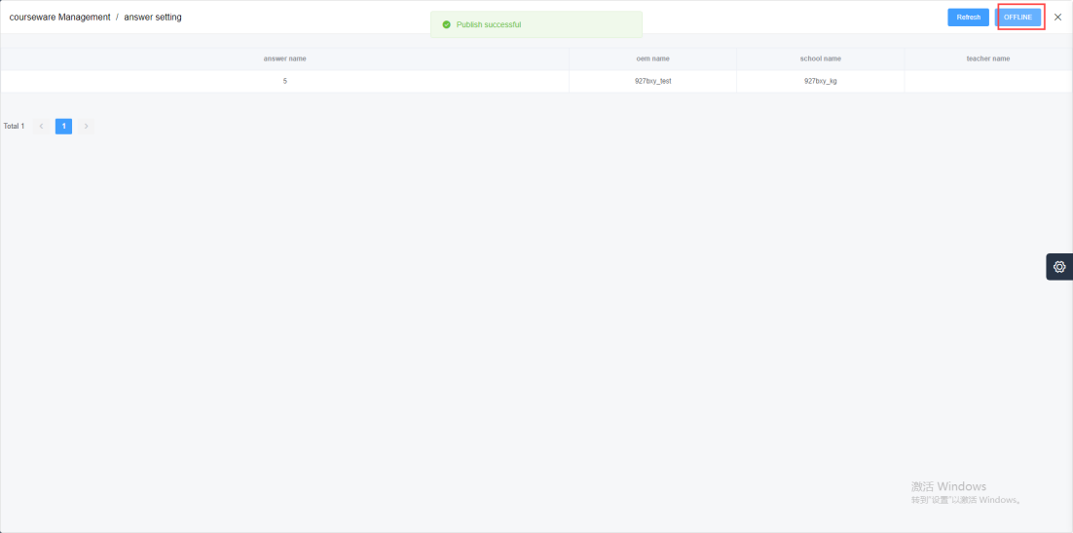

- Saving and exiting courseware
After the courseware is designed, please remember to click "Save", as shown in the figure
Click "×" to exit the courseware design page, as shown in the figure
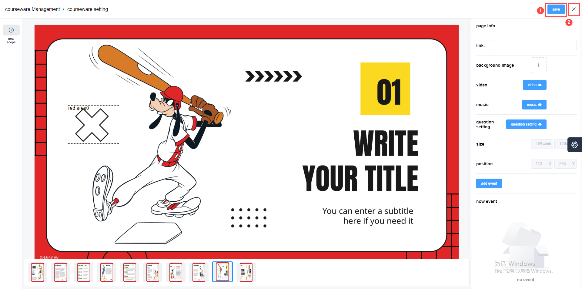

6. Courseware Editing
Click "Edit", reset the courseware information content, and click "Generate Courseware", as shown in the figure
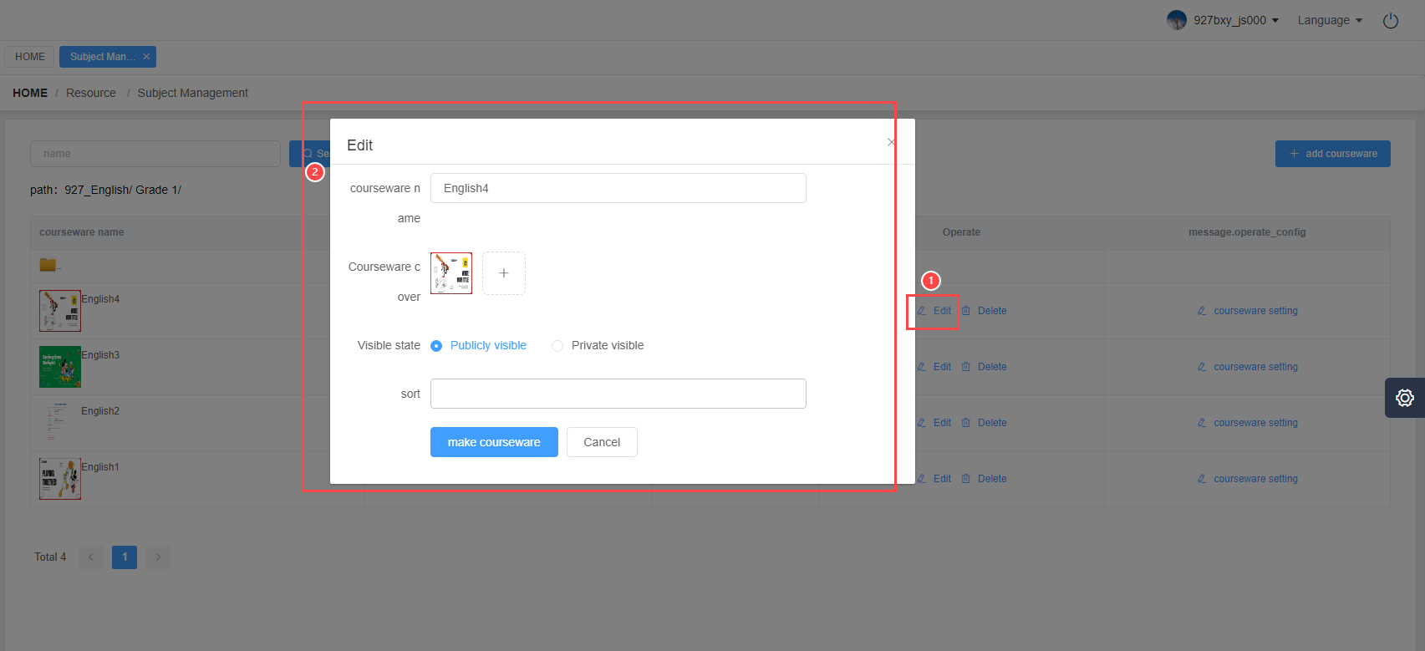

7. Courseware Deletion
Click the "Delete" button to delete the courseware, as shown in the figure
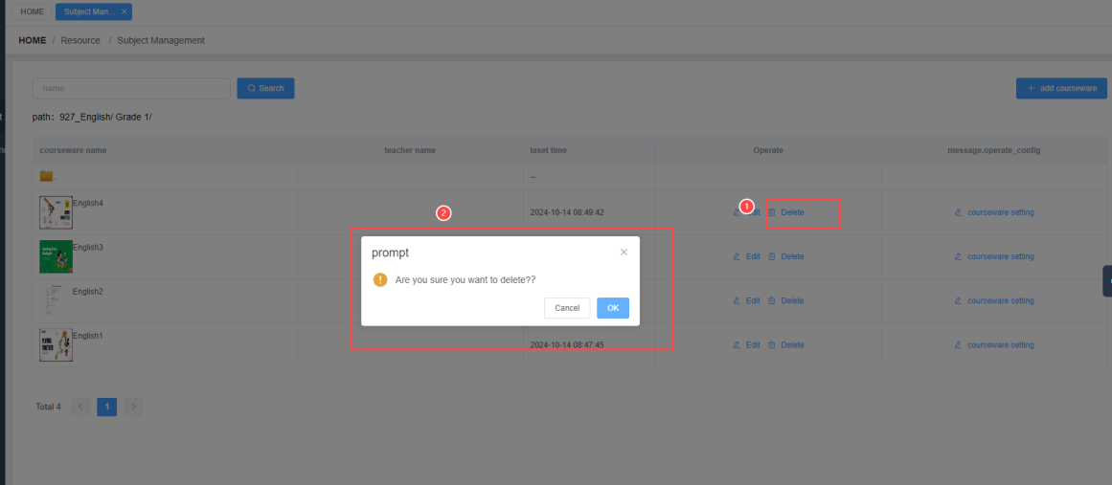

8. Log out
Click the "Exit" icon in the upper right corner to log out of the user, as shown in the figure
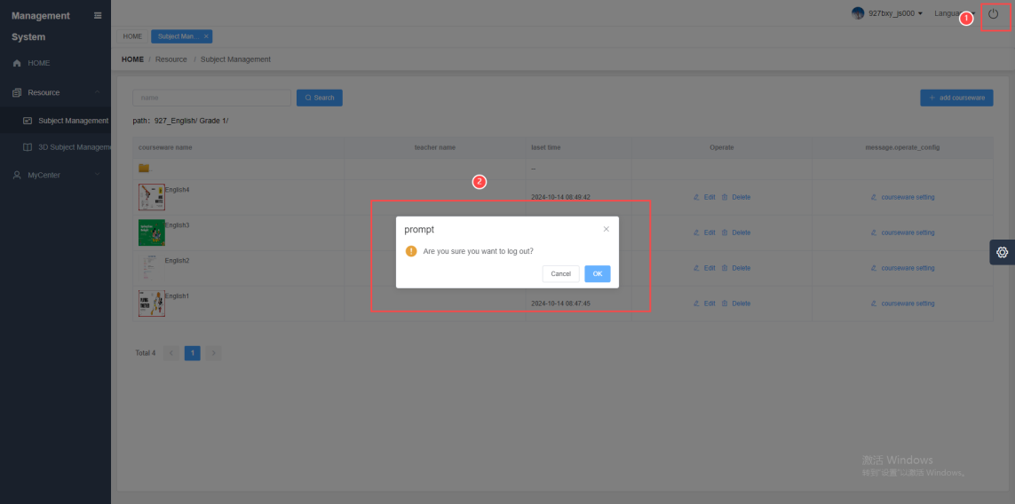

Part 2: UCourse

1. Overview
plug-in embedded in UMind . It is easy to operate, has strong classroom interactivity, and has rich teaching resources. It supports multimedia teaching methods such as pictures, audio, and video, as well as online classroom exercises. Teachers can use Ucourse in the classroom to easily conduct instant teaching in various subjects.

2. Log in to the courseware
- Start umind > plugin > Courseware as shown:
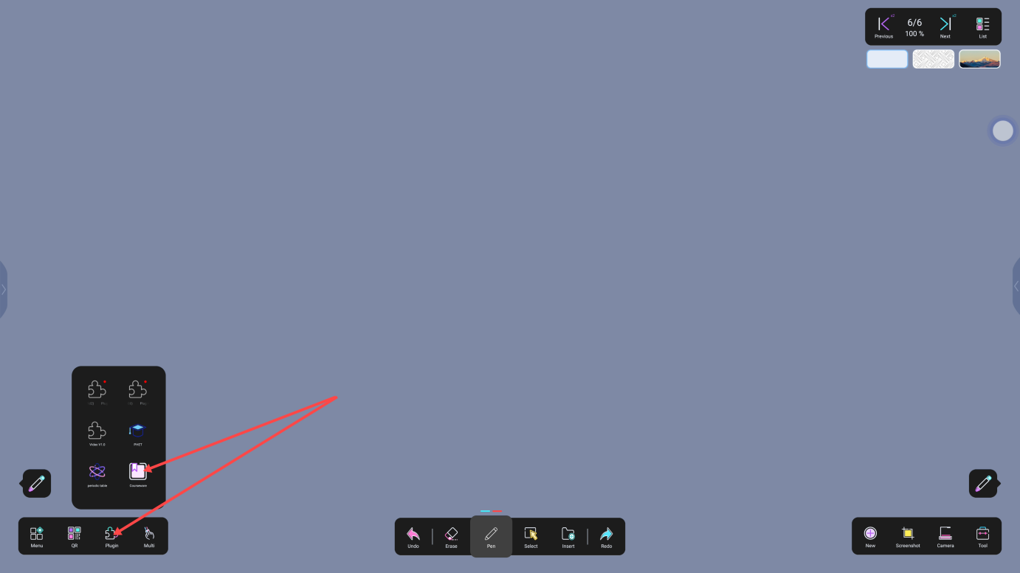

- Click the "Switch" icon, scan the QR code with your mobile phone, and enter the teacher account to log in to your personal courseware, as shown in the figure:
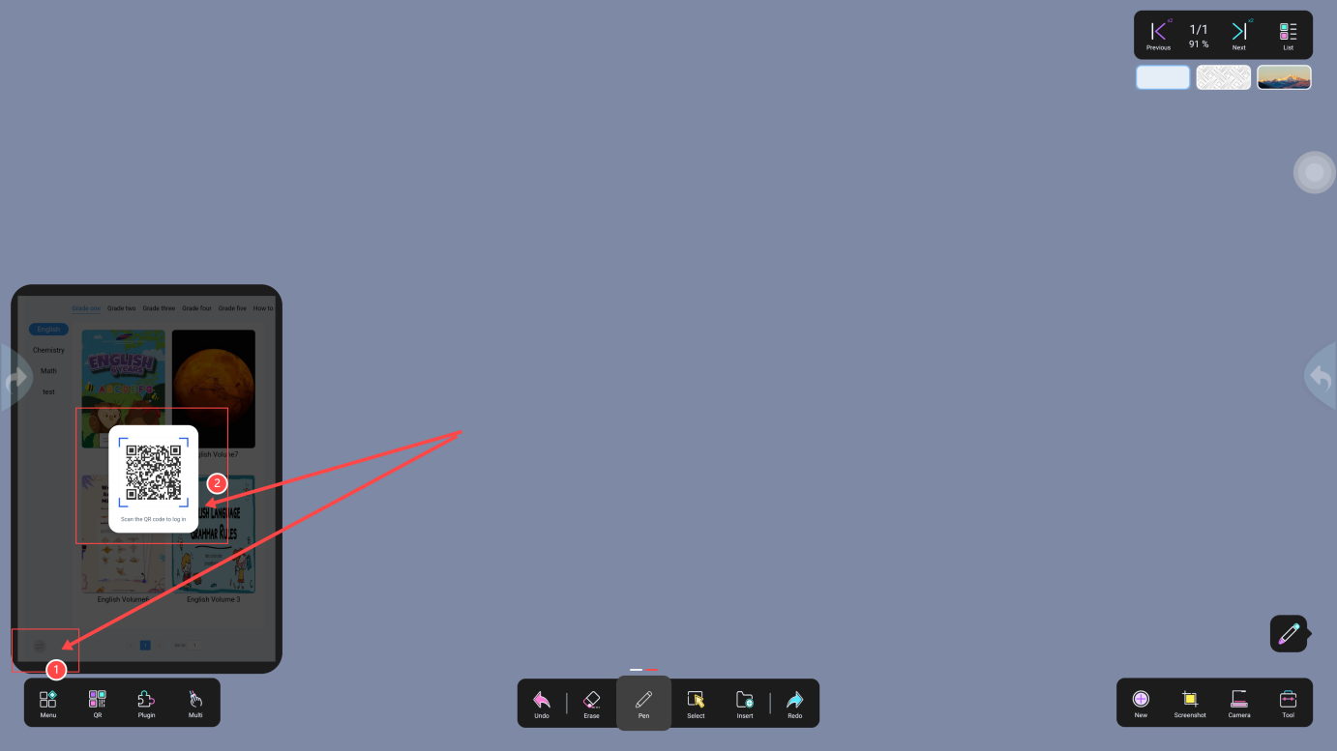

3. Courseware Demonstration

3.1 Preview and page switching
- Courseware preview, subject and grade switching are shown in the figure:
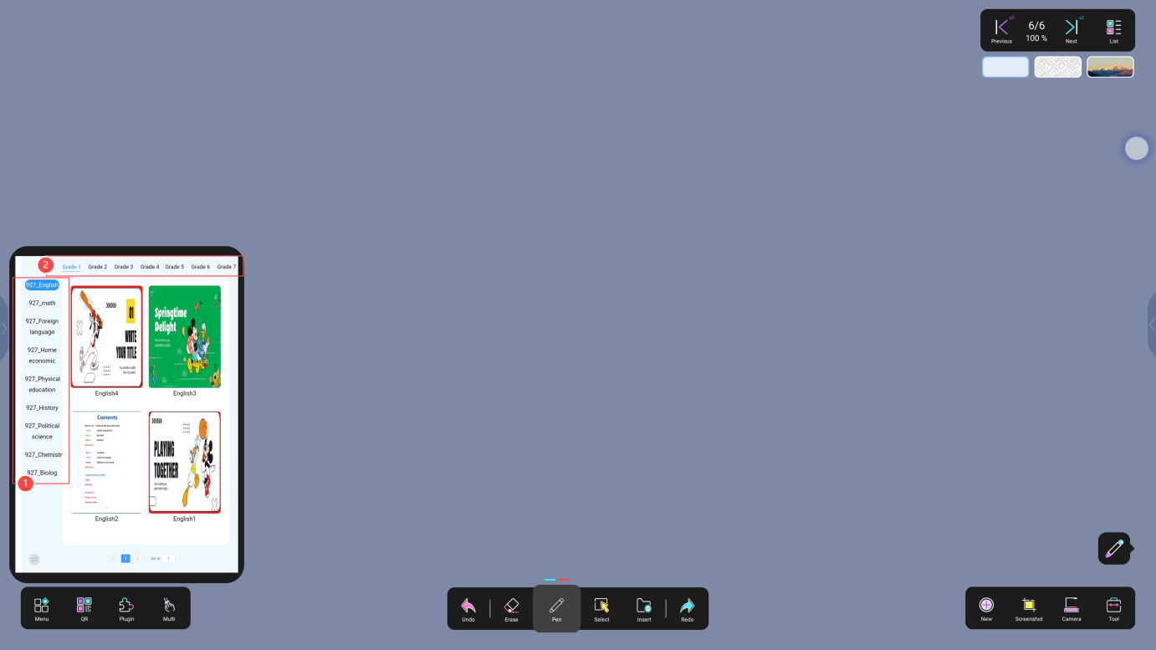

- The button turns pages and the input page jumps to the specified page as shown in the figure:
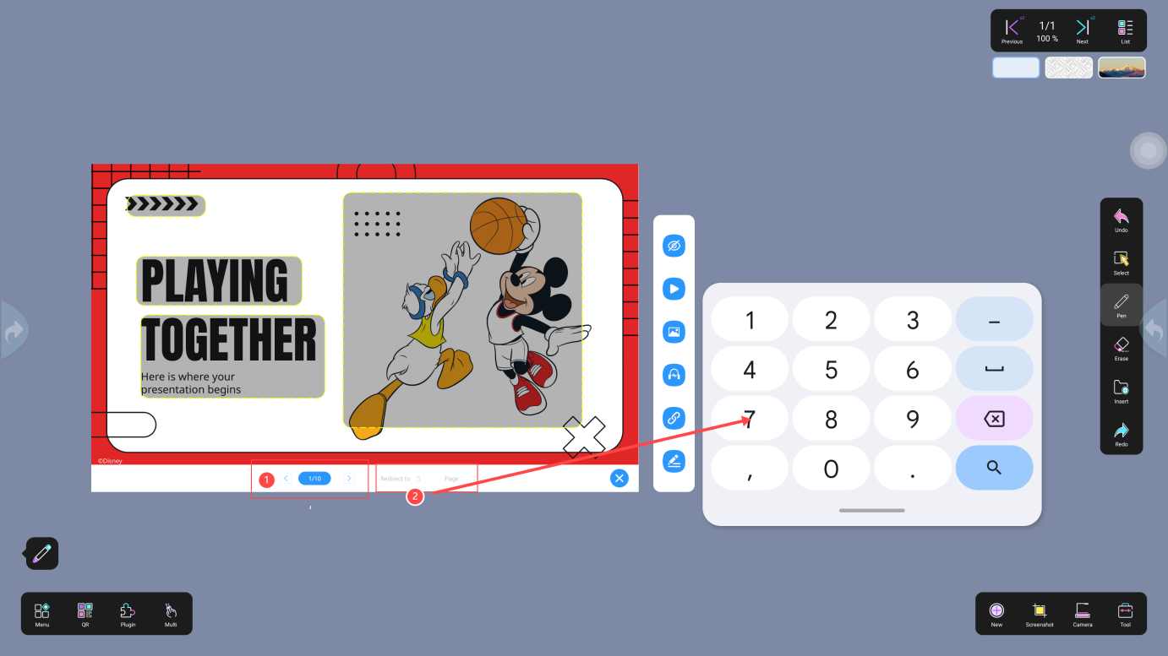

3.2 Sidebar Buttons
- Click the "eye" icon to show/hide the hot zone. The hot zone (yellow dotted box) contains video, picture, audio, and link multimedia elements, as shown in the figure:
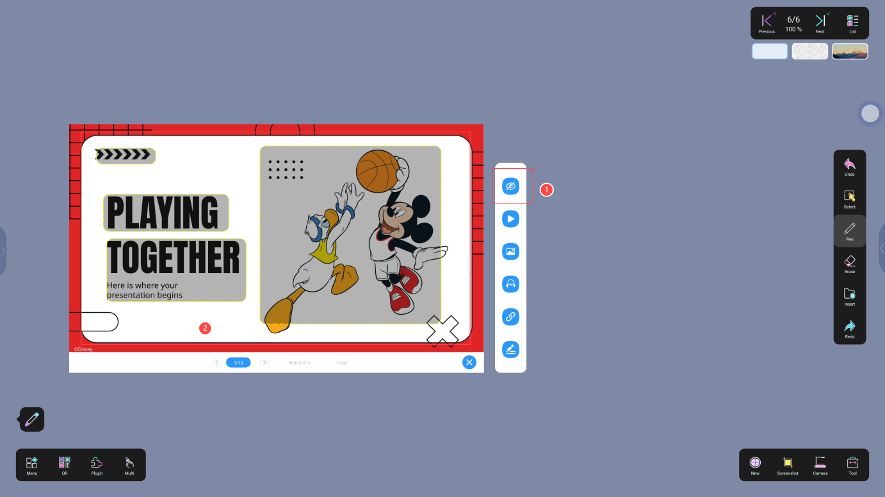

- Click the "Video" icon to trigger the preset video, which can be paused, played, fast forward, rewind, and drag the progress bar. Click the settings icon to change the speed and audio style, as shown in the figure:
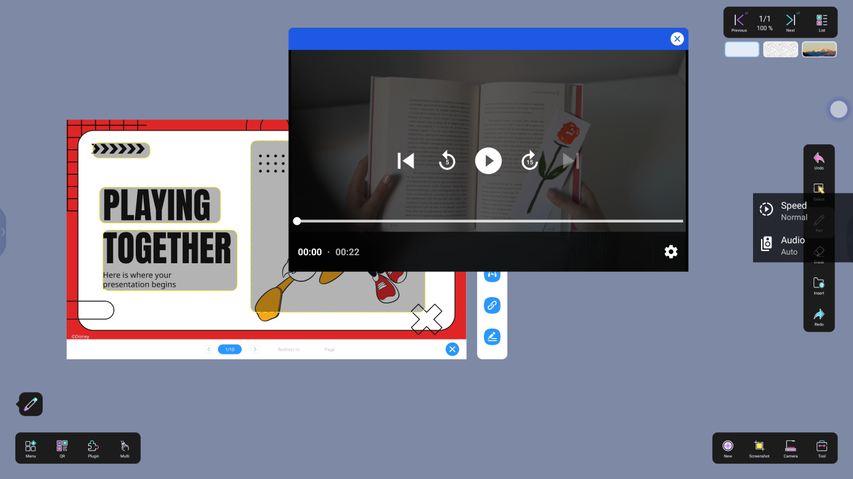

- Click the "Picture" icon to trigger the preset picture, which can be dragged, as shown in the figure:
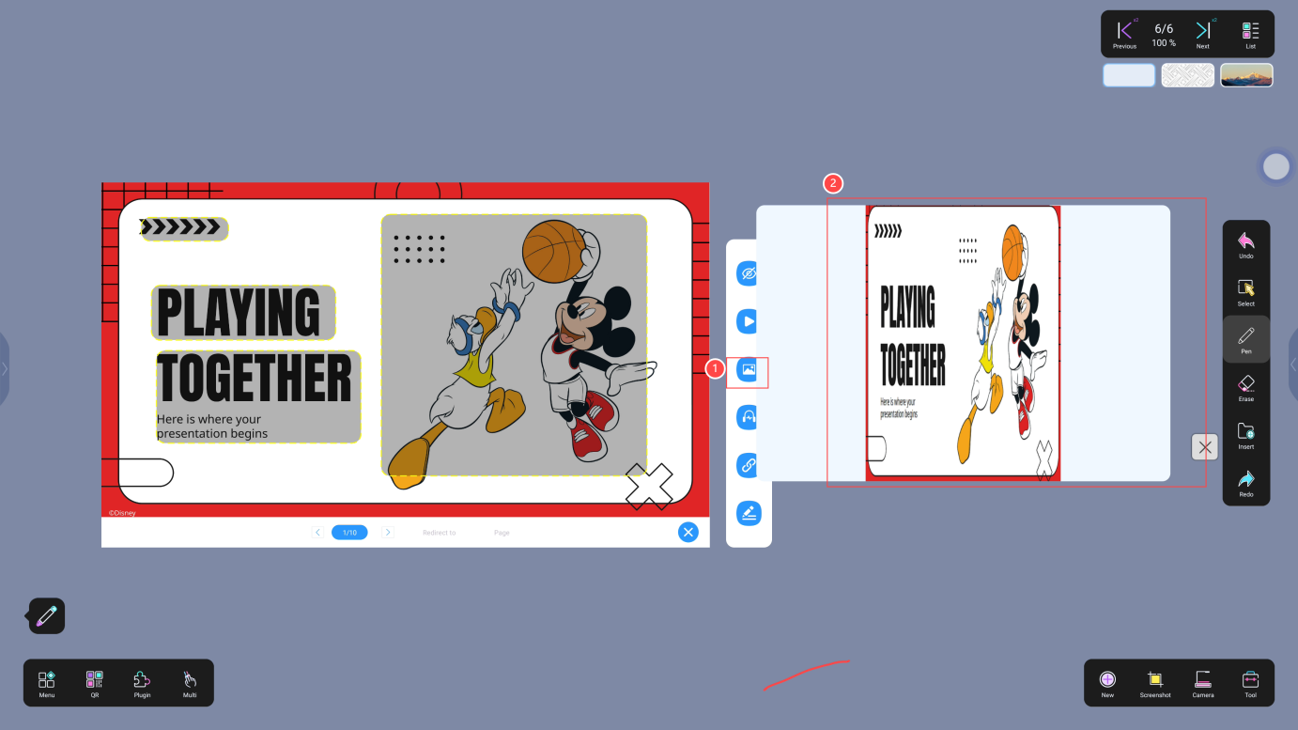

- Click the "Audio" icon to trigger the preset audio, which can be paused, played, and the progress bar can be dragged, as shown in the figure:
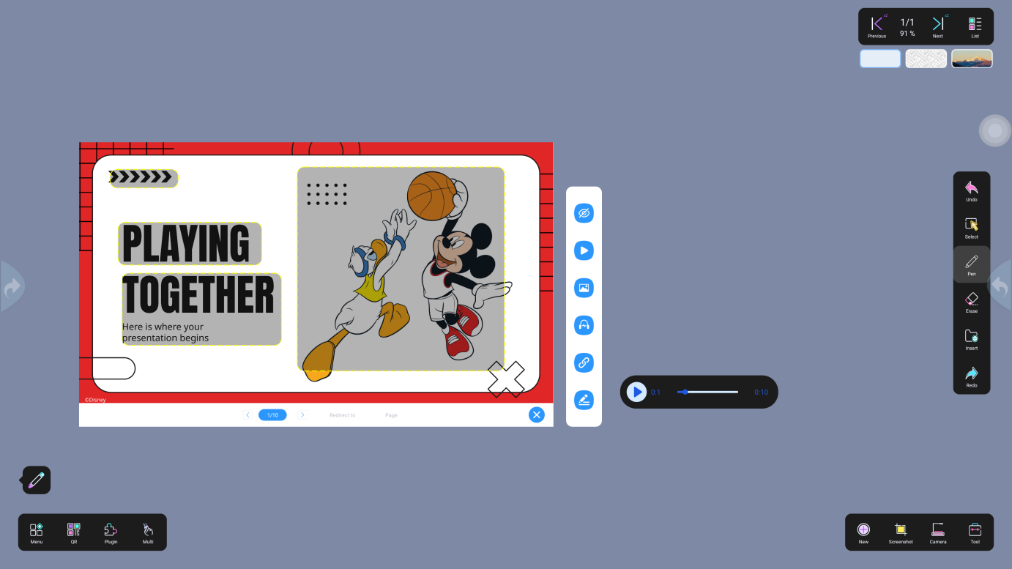

- Click the "Link" icon to jump to the link URL. Place the bottom area to drag. Select the ③ box at the bottom to switch the browser as shown in the figure:
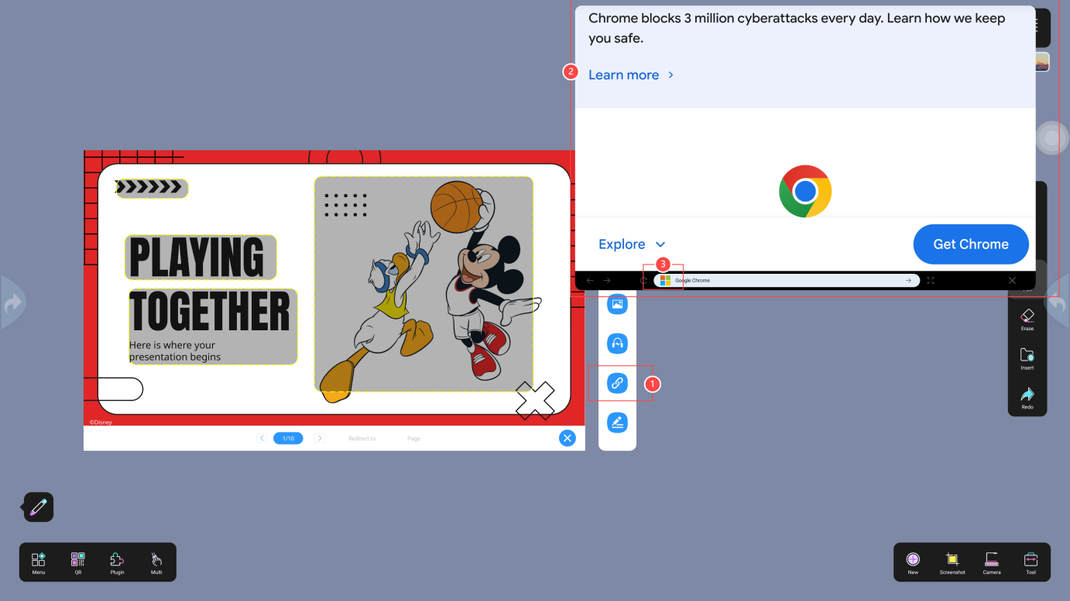

- Click the "Topic" icon to trigger the preset topic, then click "Start" to pop up a QR code. Students scan the code and enter the courseware name to answer the question, as shown in the figure:
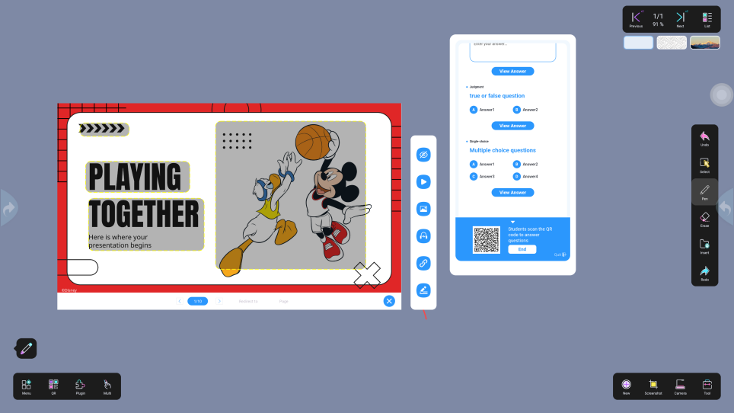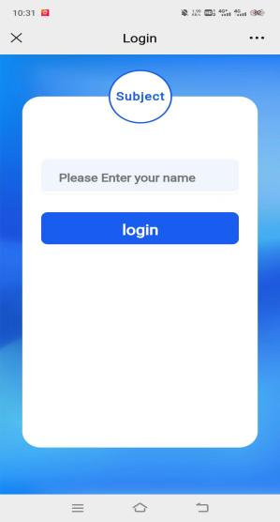

- The student answer page is shown in the figure:
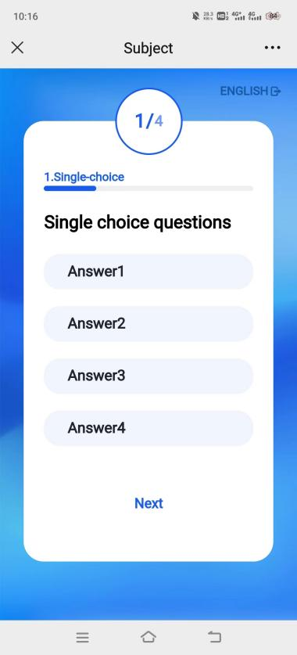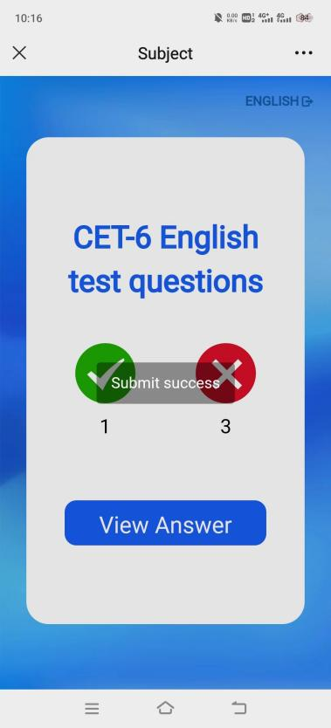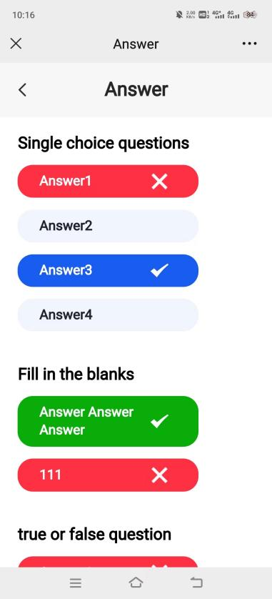

- Click "End Questioning" to view the answer rate, as shown in the figure:
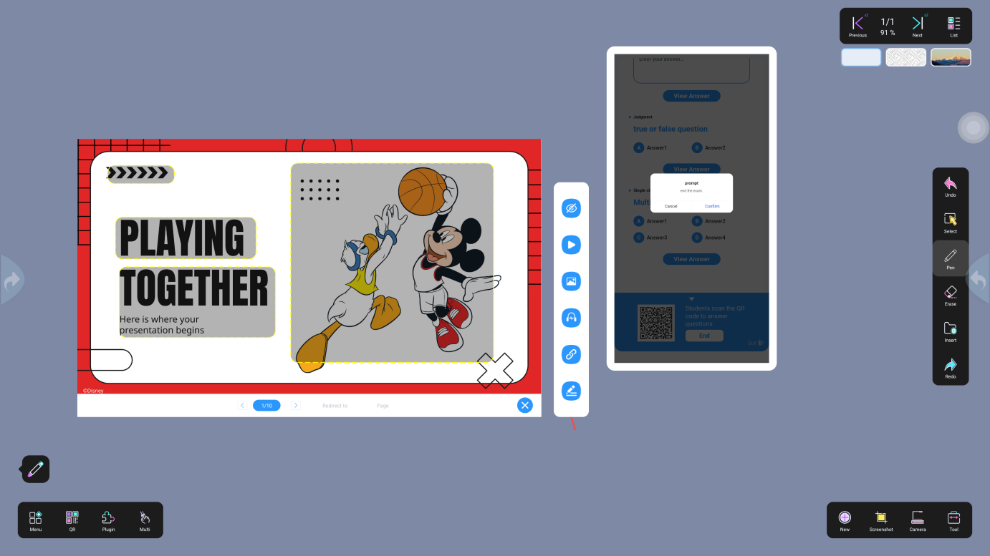

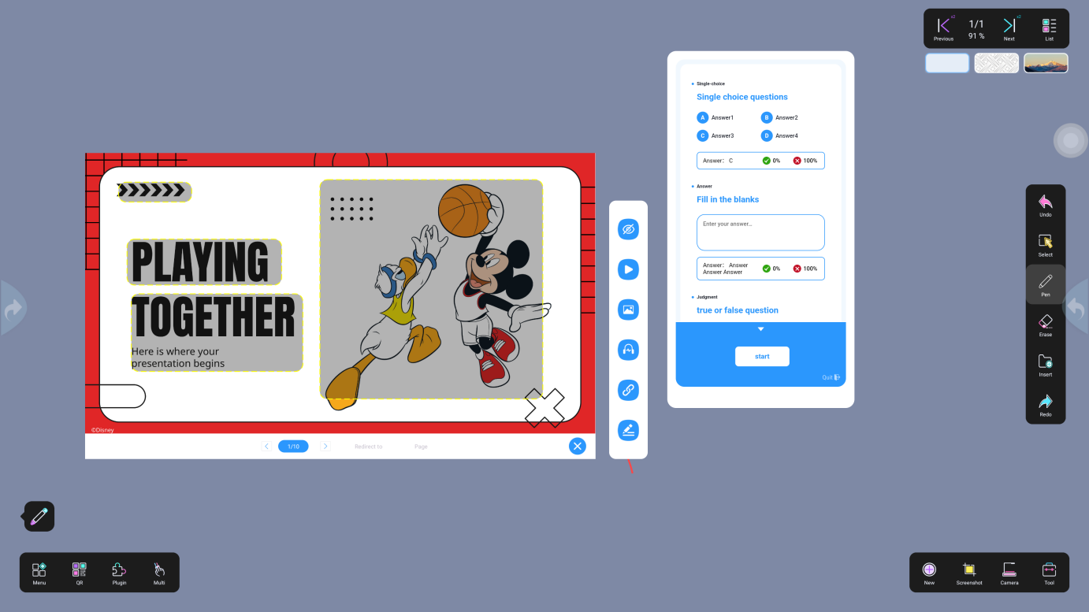

- Click the "Exit" button to exit the question page, and the QR code will pop up as shown below:
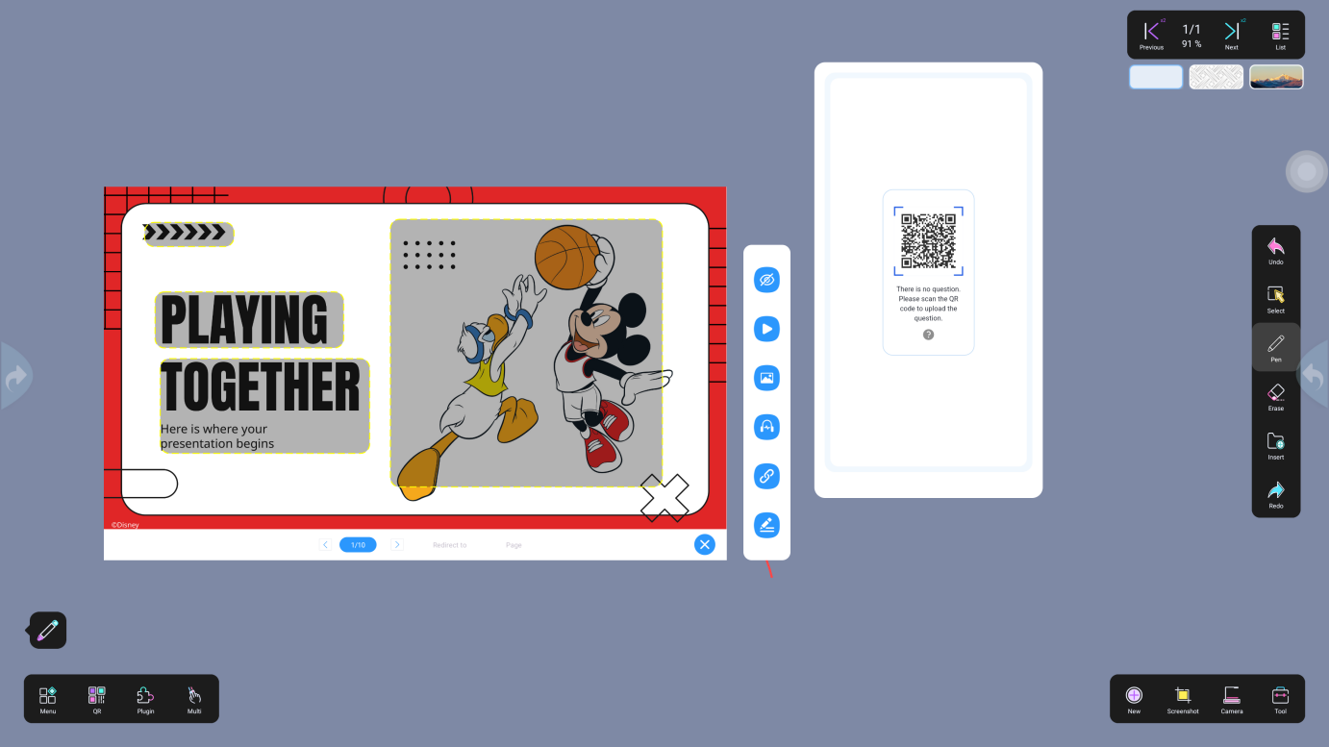

- Scan the QR code with your mobile phone and enter your account number. Edit the title, publish, and remove it from the shelves online on the mobile phone. The exit operation is as shown in the figure:
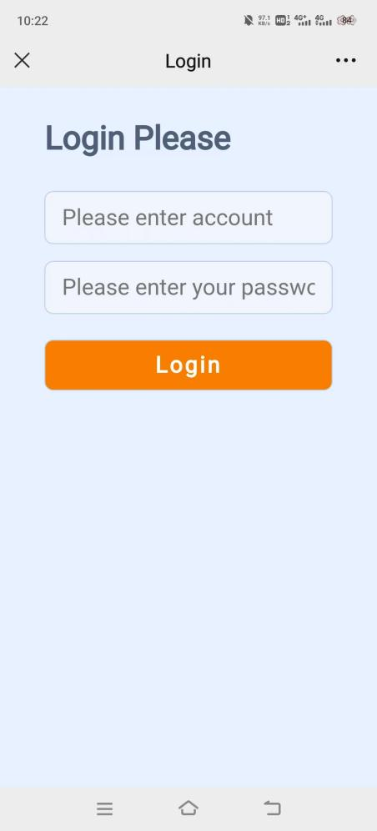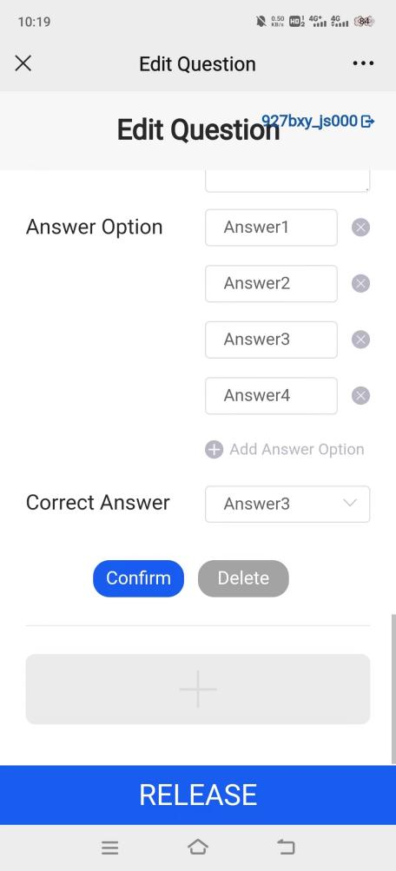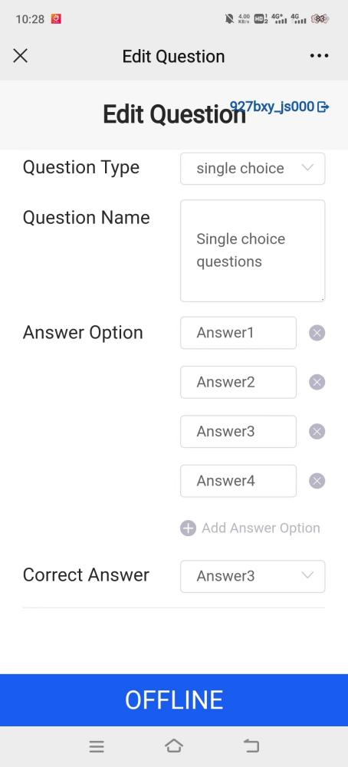

- Exit Courseware
- Click the toggle button and select "Exit", as shown in the figure
