Dong Guan Riotouch Technology Co.,Ltd

RioTouch DMS
User Manual

Table of contents
1. Add a device 4
2. Add groups 5
3. Device Control 6
3.1 Equipment Control_Basic Control 8
3.1.1 Power Management 8
3.1.2 Screen Management 11
3.1.3 Message Settings 13
3.2 Equipment Control_Upgrade Management 14
3.2.1 Testing 14
3.3 Device Control_System Settings 16
3.3.1 Parameter settings 16
3.3.2 Wired Network 19
3.3.3 Wireless Network 19
3.4 Device Control_Custom Commands 20
3.4.1 Create Command 20
3.4.2 My Commands 20
3.5 Equipment Control_File Management 21
3.5.1 File Transfer 21
3.5.2 Installation 23
3.6 Equipment Control_Workflow 24
4. Operation 27
4.1 Operation_View details 27
4.2 Operation_Permission Allocation 27
4.3 Operation_Edit 29
4.4 Operation_Delete 30

1. Add a device
Click "Add Device" and a pop-up window will appear. Enter information such as mac, OEM, model, region, etc. Click the "Submit" button. The mac will be bound to the OEM customer and the customer will have the permissions of the mac. Admin/OEM can perform this "add device" operation .
Status:
Enable: the device has been reviewed and cannot be deleted;
Close: the device has not been reviewed and can be deleted;
Background lock:
Enable: the device is locked and you need to enter the offline password;
Close: the device is unlocked;

- Admin "Add device", as shown in the figure
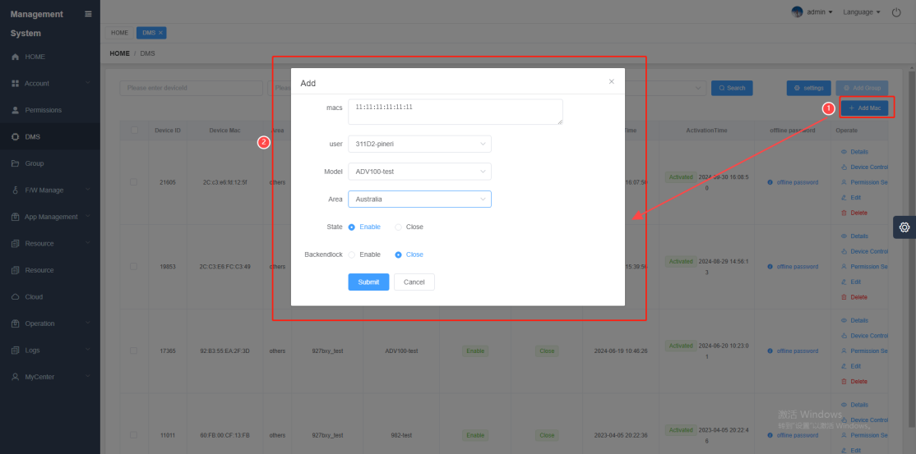

- OEM "Add Device" as shown in the picture
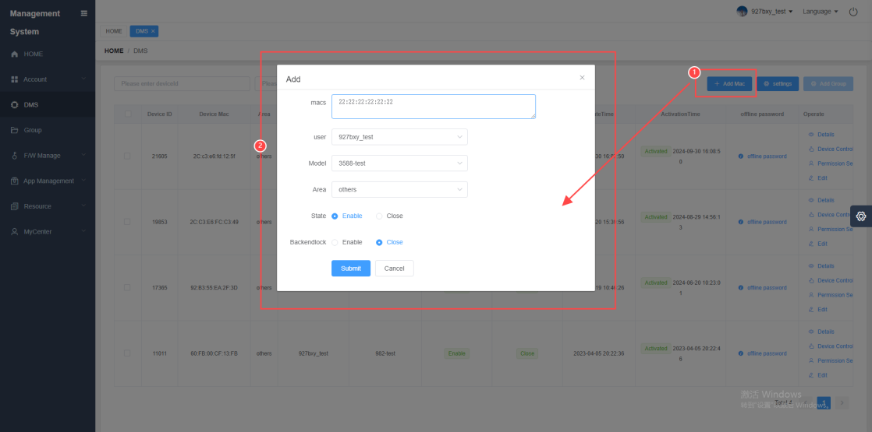

2. Add groups
Select the device, click "Add Group", fill in the new group name or select the group from the drop-down box, and click "Add"; the created group will be displayed in the group management, and supports Admin/OEM/School to do this "Add Group" operation
- Admin "Add Group", as shown in the figure
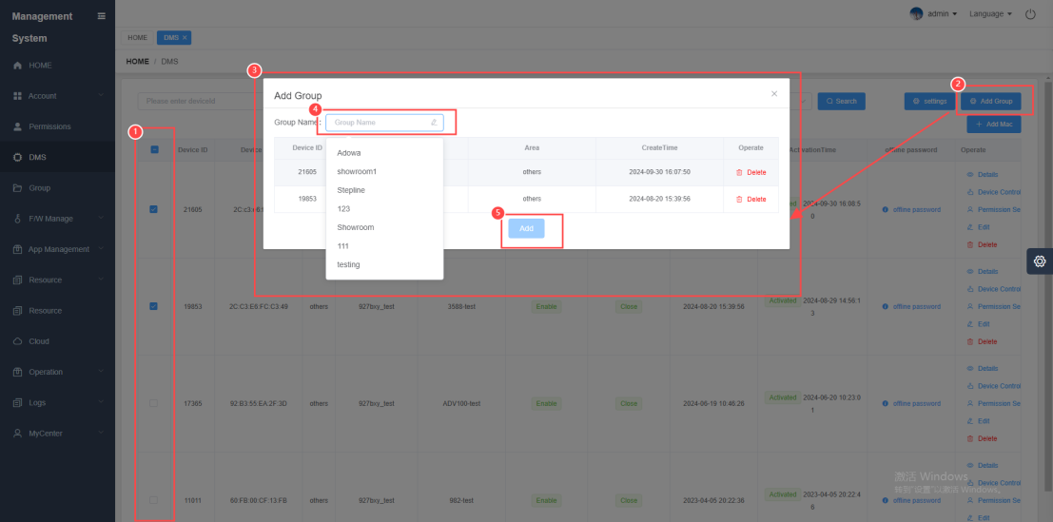

- OEM "Add Group", as shown in the picture
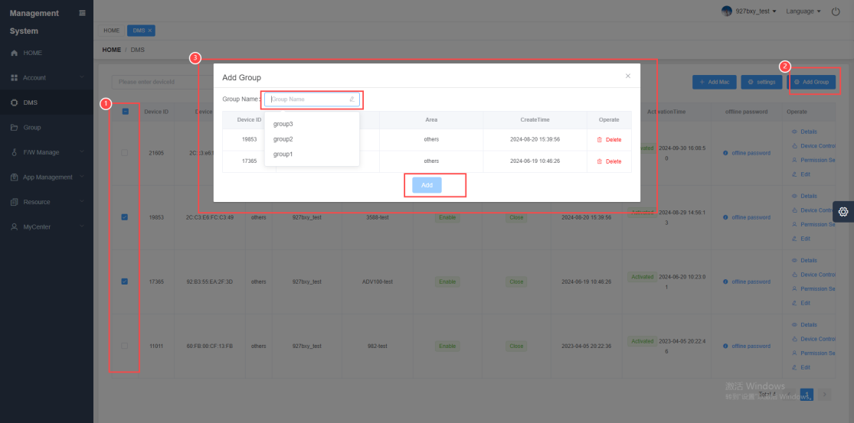

- School "Add Group", as shown in the figure
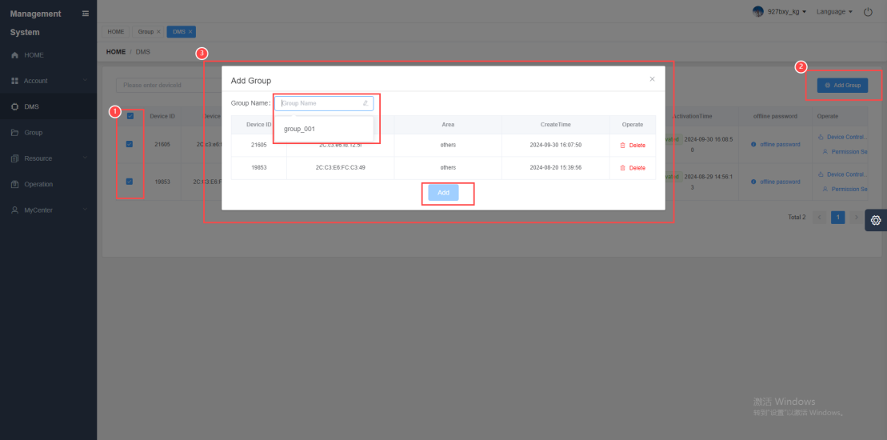

3. Device Control
- Client
the DMS of the corresponding motherboard on the client , connect to the network, open the DMS display online, and then control the device
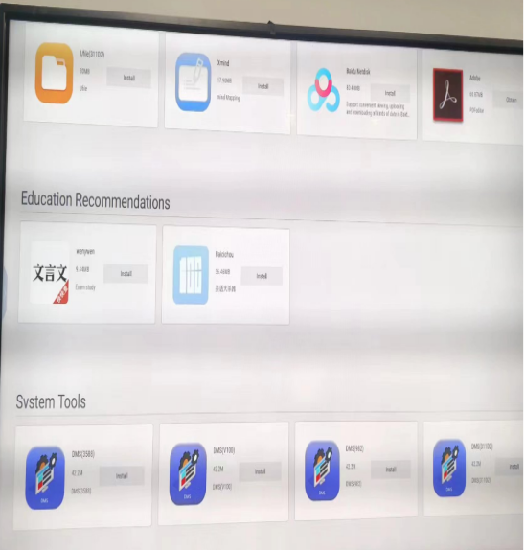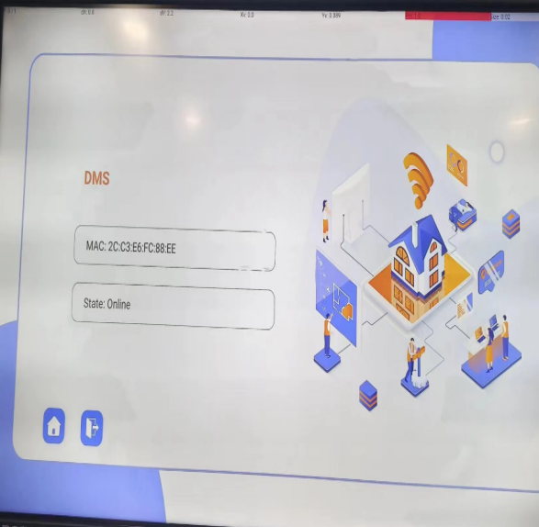

- Cloud Platform
There are two paths for device control. As long as the permission is granted, Admin/OEM/School can control their devices.
Path ① : Click Settings to enter
Path ② : Click Operation_Device Control in the device list
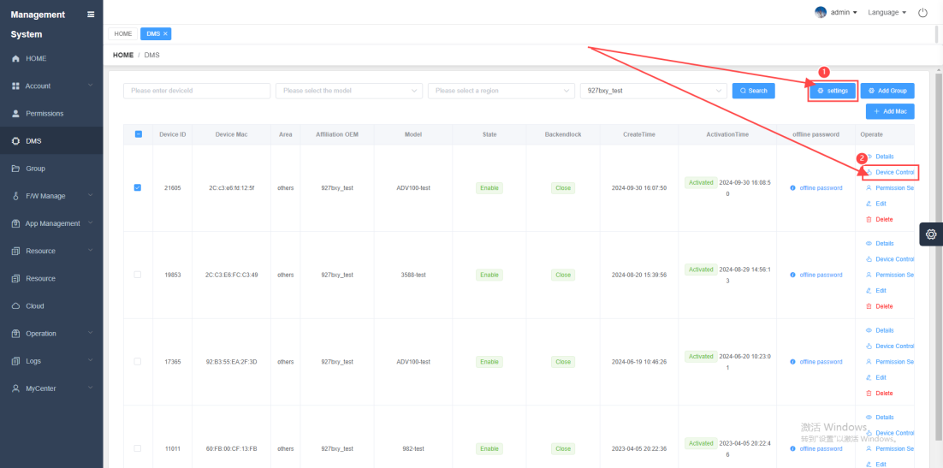

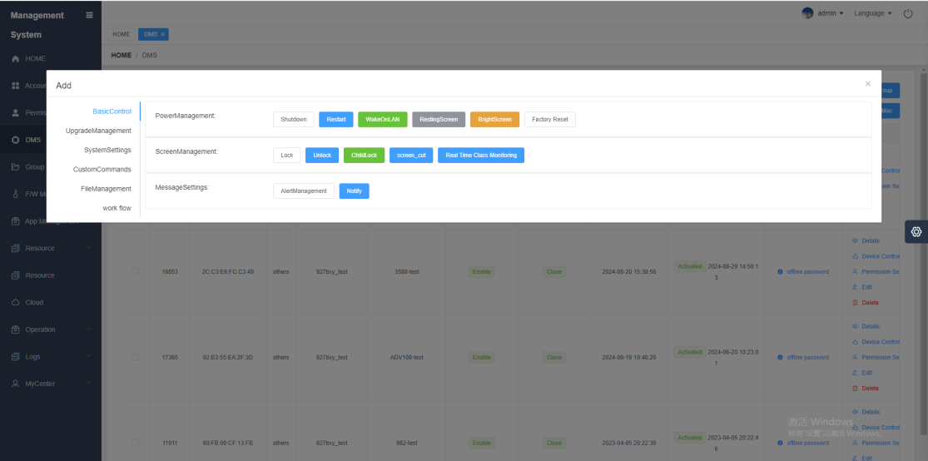

3.1 Equipment Control_Basic Control

3.1.1 Power Management
- Shutdown
The device responds to the "shutdown" command and shuts down.
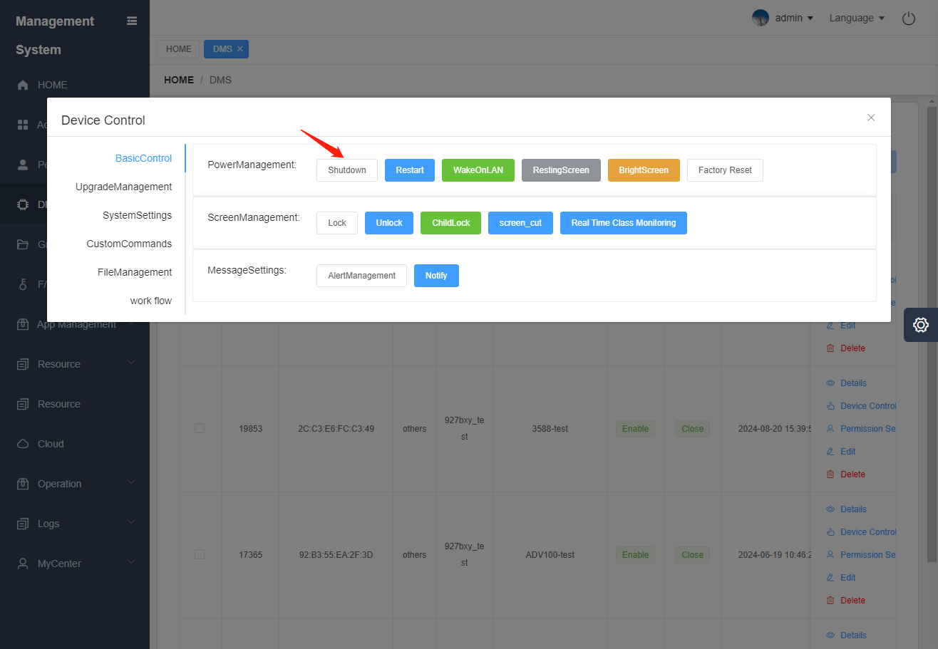

- Restart
The device responds to the "restart" command and restarts
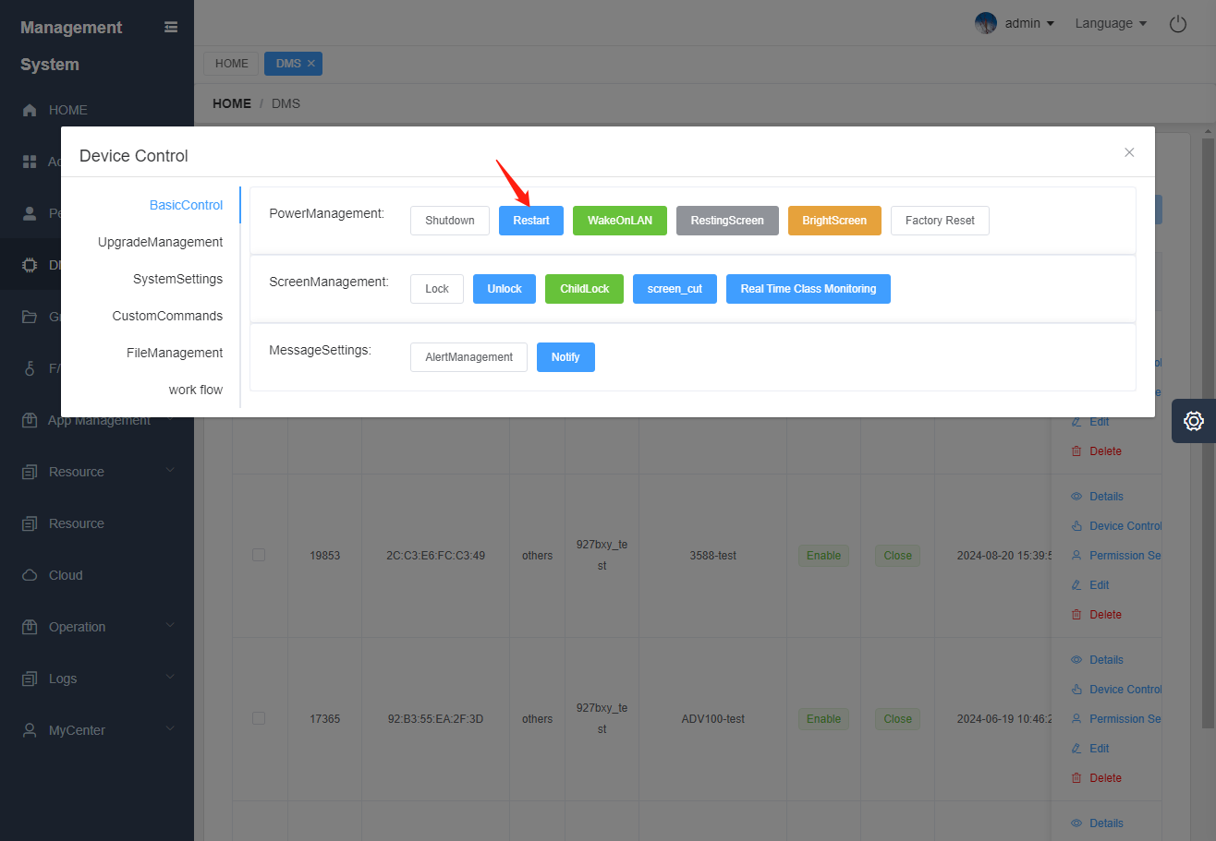

- Network wake-up (not supported yet, this function will be opened later)
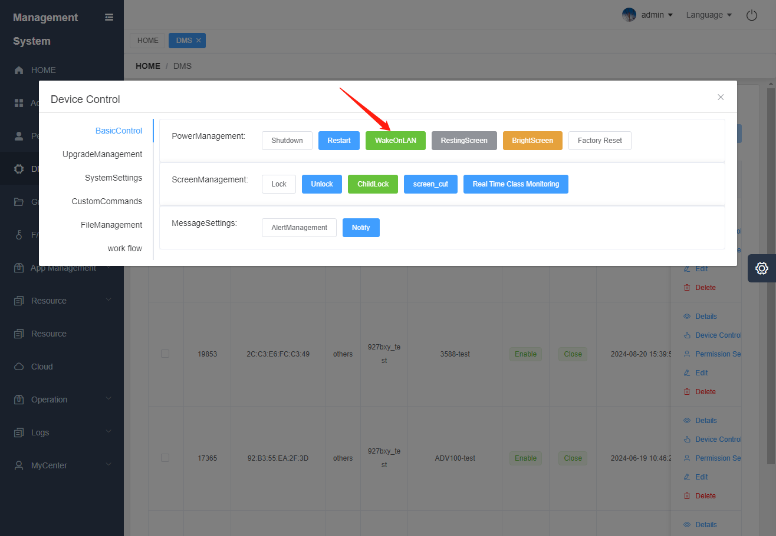

- Screen off
The device responds to the "Screen Off" command and the device turns off the screen
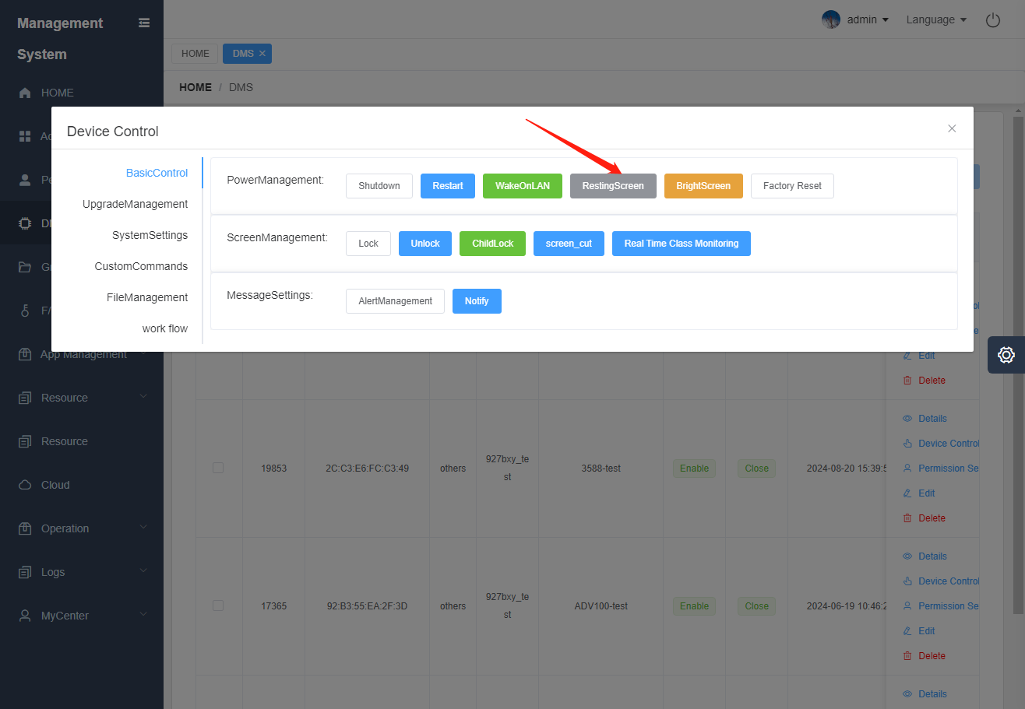

- Bright screen
The device responds to the "turn on screen" command and turns on the screen
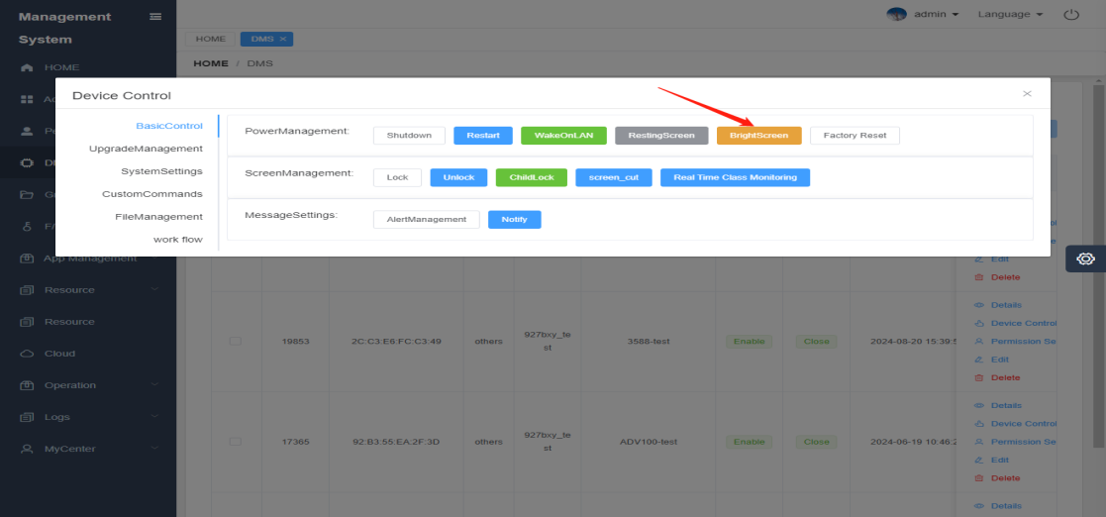

- Restore factory settings
The device responds to the "factory reset" command and enters the factory reset state
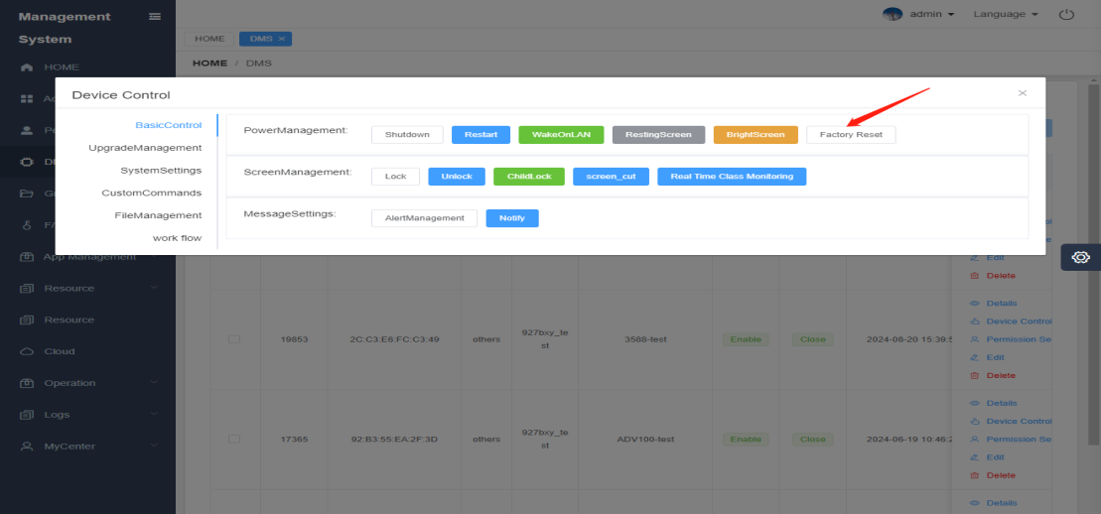

3.1.2 Screen Management
- locking
The device responds to the "lock screen" command, the device enters the lock screen state, and the lock screen icon appears in the lower right corner of the client
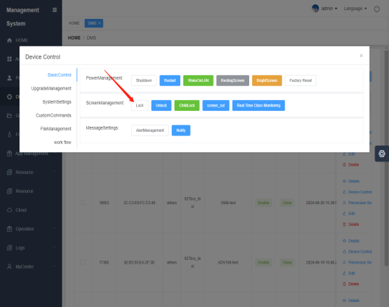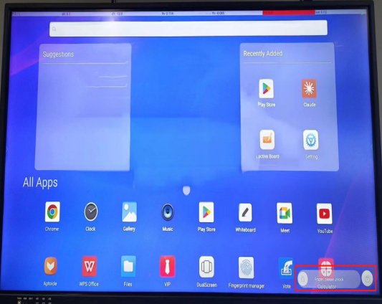

- Unlock
The device responds to the "unlock" command, the device is unlocked, and the lock screen icon in the lower right corner of the client disappears
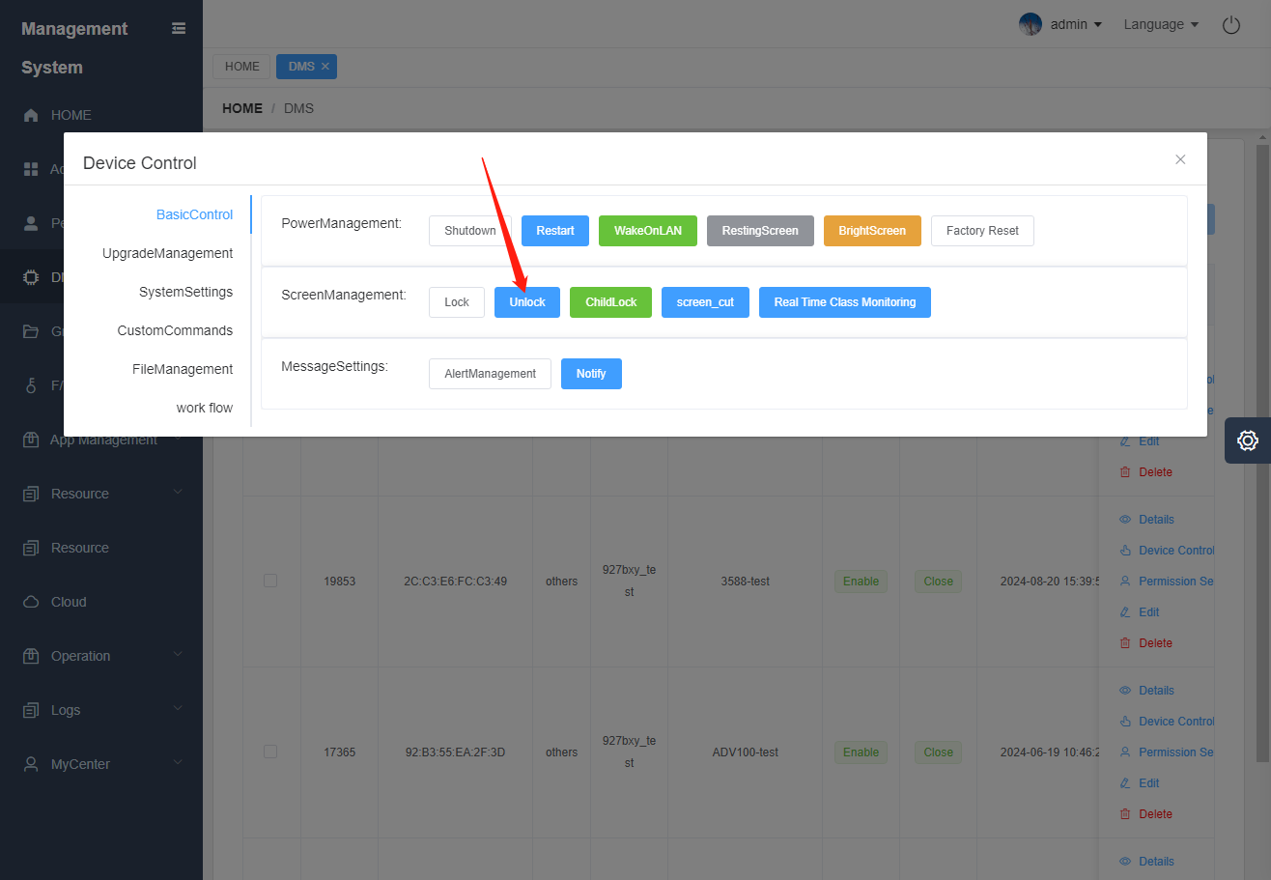

- Child lock
Click "Child Lock" and enter the "Password" to submit; the device responds to the "Child Lock" command, the device turns on the child lock, and you need to enter the password to unlock it
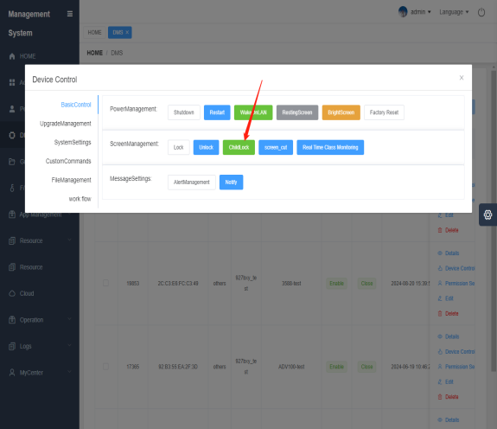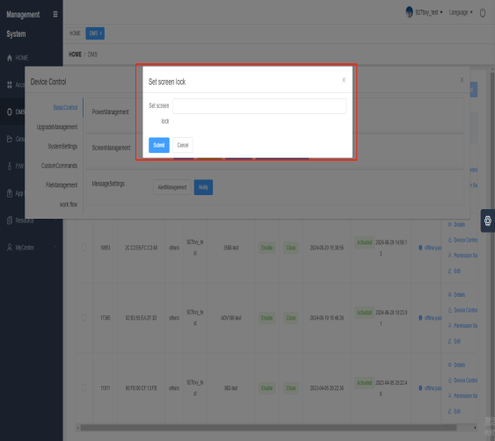
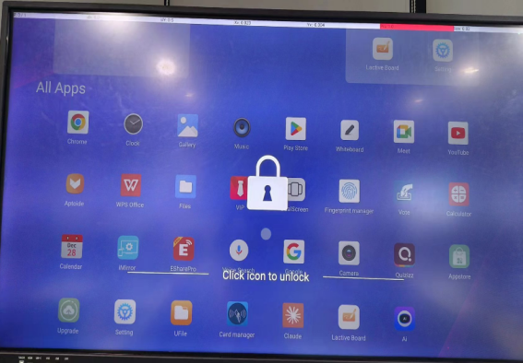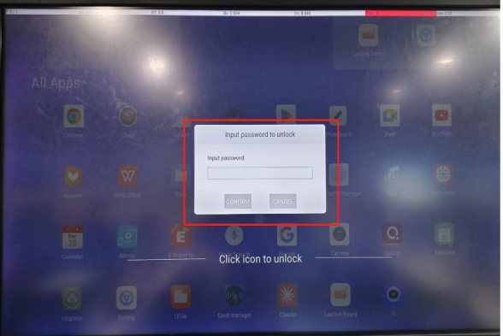

- screenshot
The device responds to the "screen capture" command, captures the current screen of the device, and displays the screen on the computer control end.
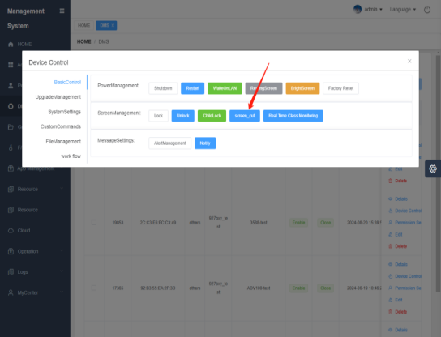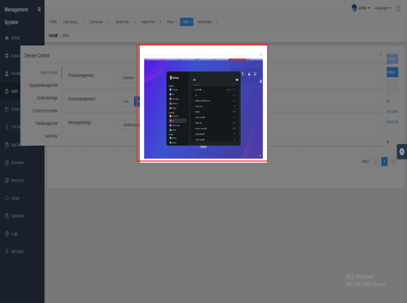

- Online inspection
The device responds to the "online inspection" command, and the device calls the camera to shoot the picture in real time, and the picture is displayed on the computer control screen.
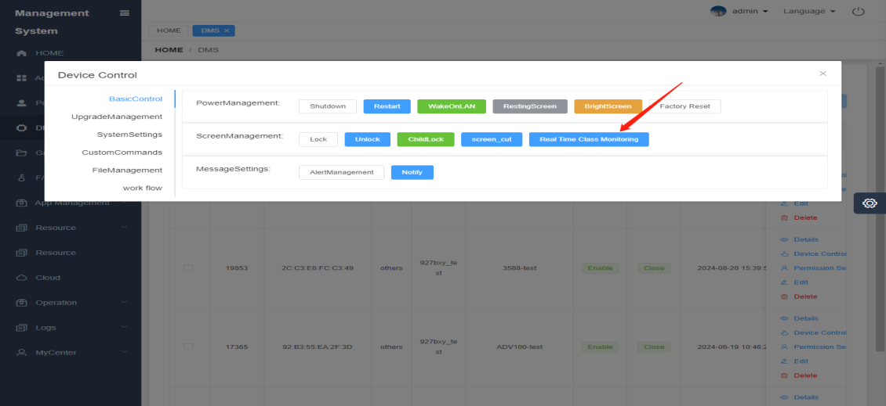

3.1.3 Message Settings
- Send Alert
The device responds to the "Send Alarm" command and sounds an alarm
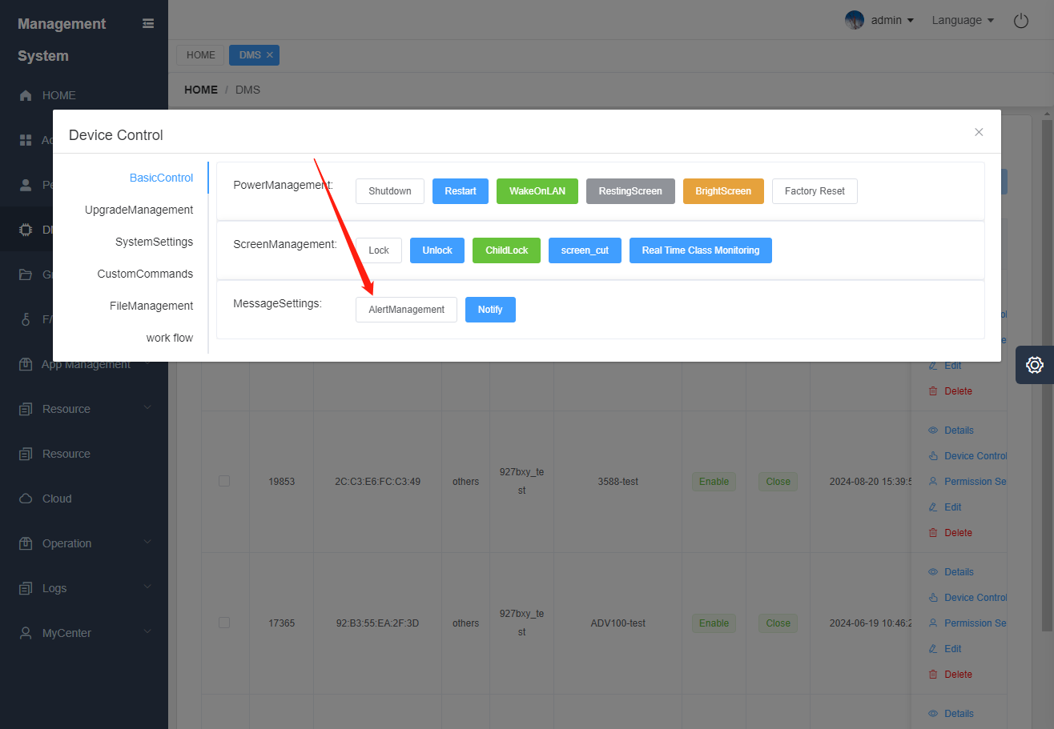

- Message Notification
The device responds to the "Message Notification" command, and a message pops up on the device screen, which is consistent with the edited title and notification content.
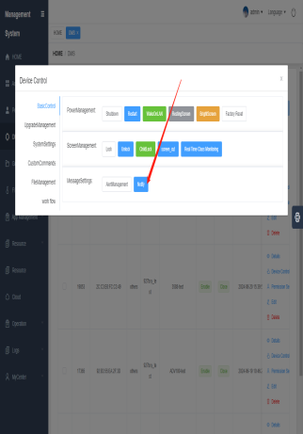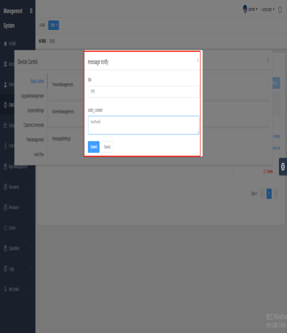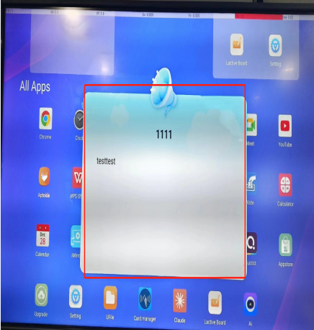

3.2 Equipment Control_Upgrade Management

3.2.1 Testing
- Touch Test
The device responds to the "touch test" command. Touching can light up all the squares, and the test passes when all the squares change from white to blue, as shown in the figure.
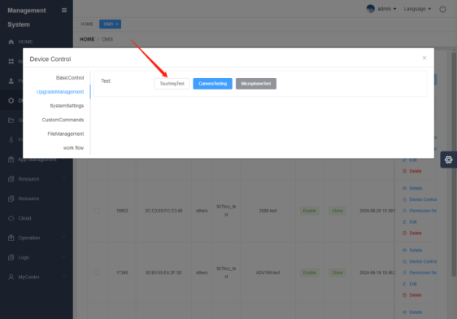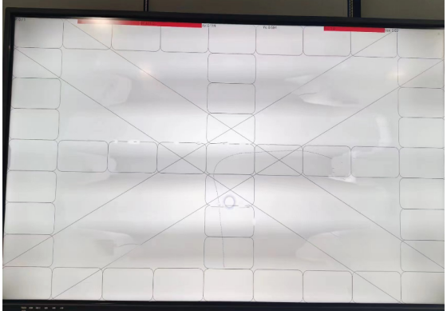

- Camera Test
The device responds to the " camera test " command, and the device calls the camera to shoot the picture in real time, and the picture is displayed on the computer control screen

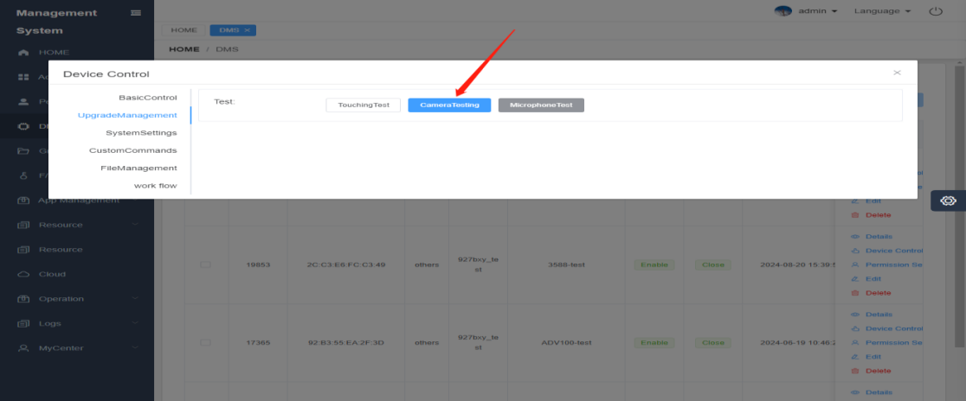

- Microphone Test
The device responds to the " microphone test " command and calls the device microphone
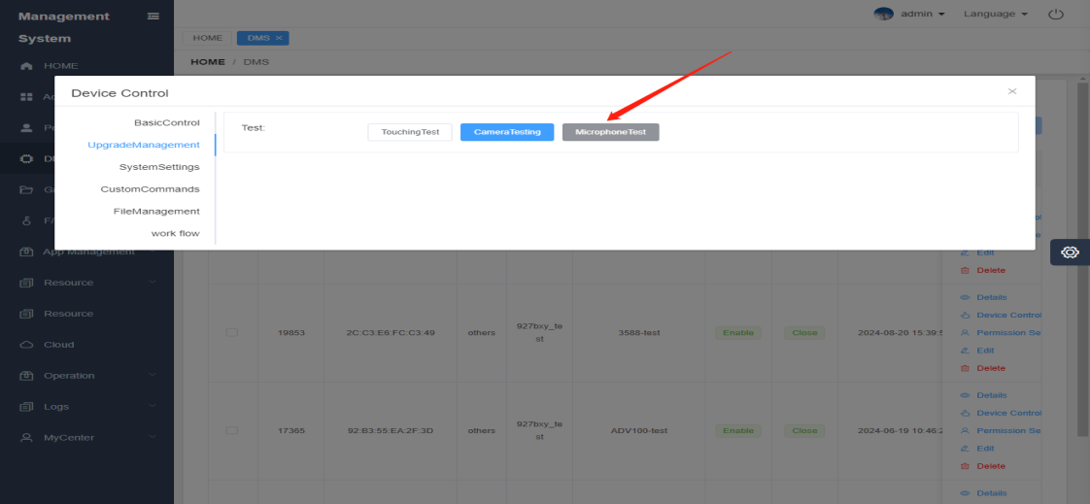

3.3 Device Control_System Settings

3.3.1 Parameter settings
- Backlight
The device responds to the " backlight " command, and the backlight brightness changes with the custom adjusted brightness value
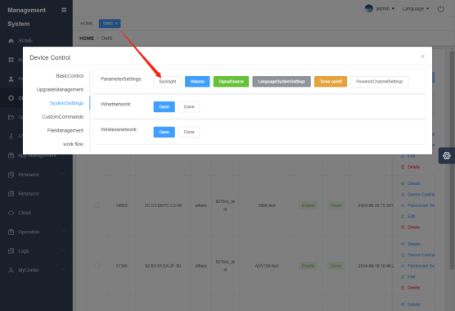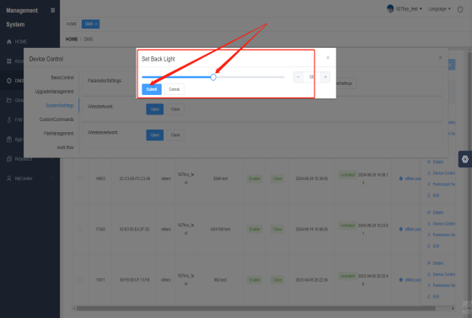

- volume
The device responds to the " volume " command, and the audio and video sounds change with the background adjustment.
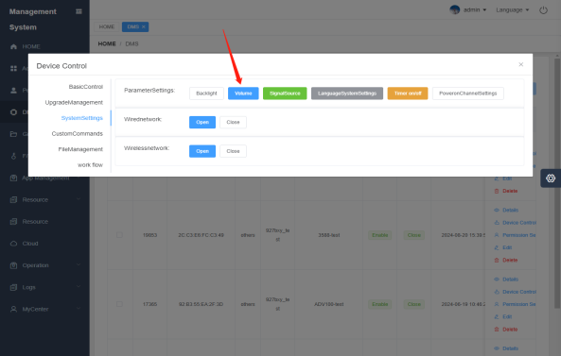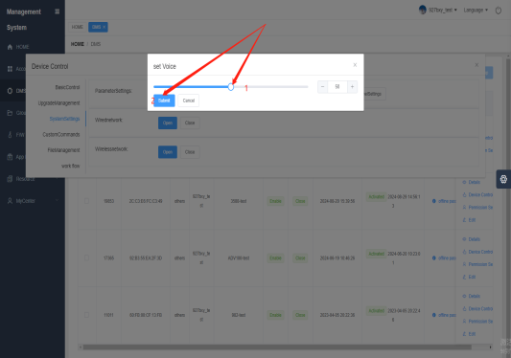

- Signal Source
The device responds to the " signal source " command, and can jump to the corresponding channel by selecting different signal sources.
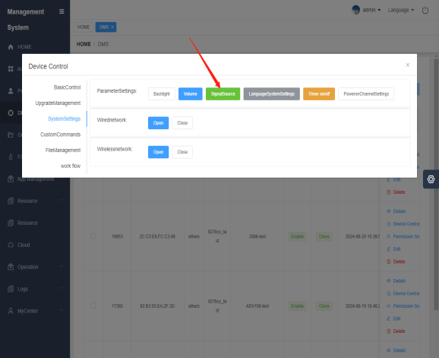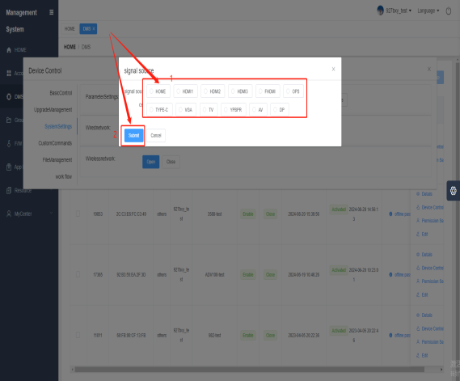

- Language system settings
The device responds to the " language system settings " command, and the system language can be changed correctly each time the language is changed
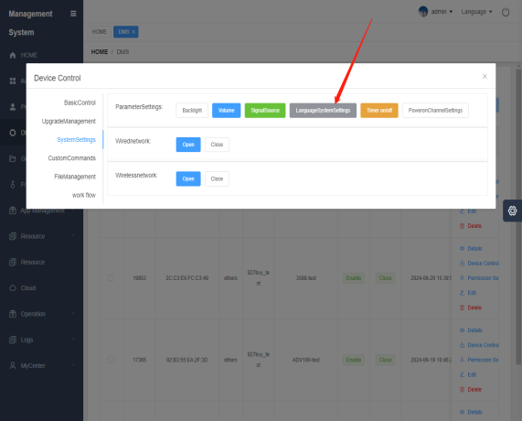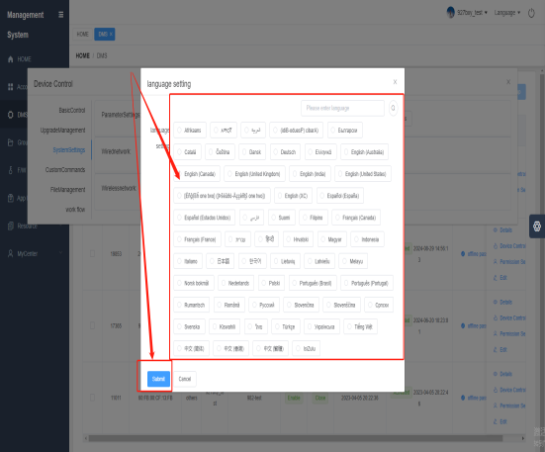

- Timer switch
The device responds to the " scheduled power on/off " command (not supported yet, this function will be opened later)
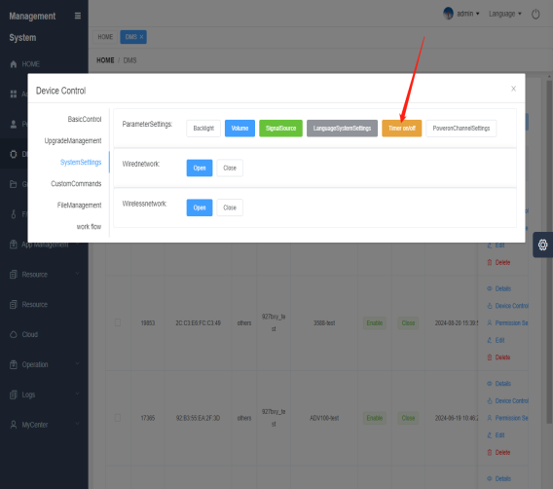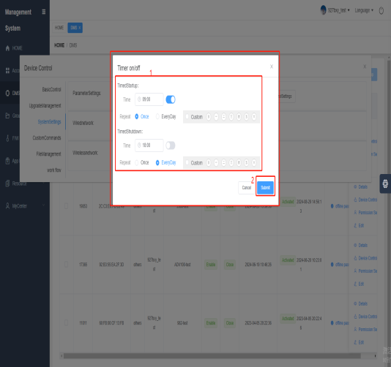

- Power-on channel settings
The device responds to the " Power On Channel Setup " command
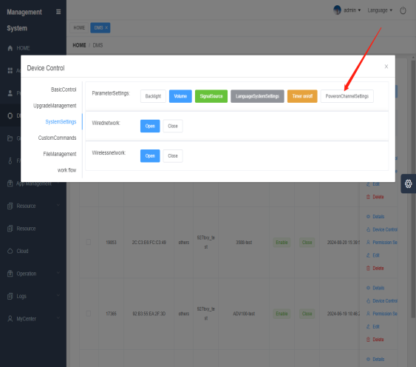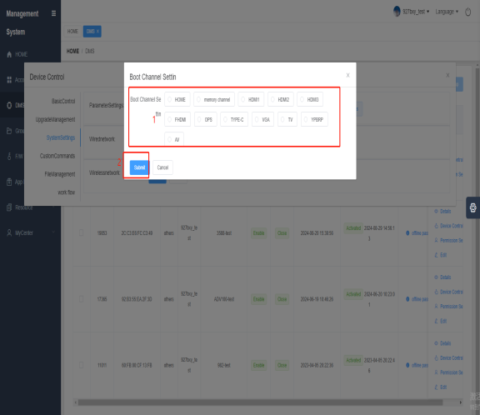

3.3.2 Wired Network
The device responds to the wired network switch. If it is turned on, the wired network is turned on, and if it is turned off, the wired network is disconnected.
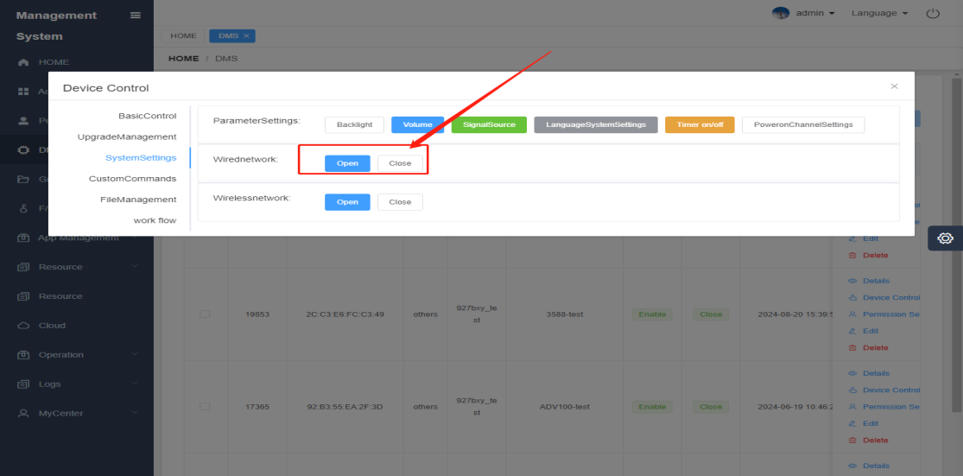

3.3.3 Wireless Network
The device responds to the wireless network switch. If it is turned on, the wireless network is turned on, and if it is turned off, the wireless network is disconnected.
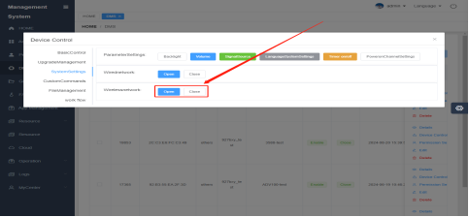

3.4 Device Control_Custom Commands

3.4.1 Create Command
Allows users to define and execute a series of operations based on specific needs to achieve precise control and management of devices
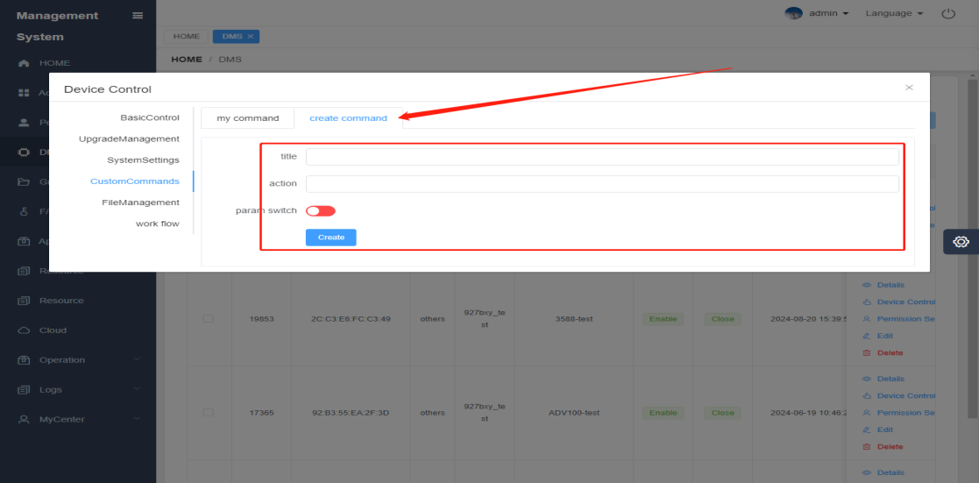

3.4.2 My Commands
The created command is in the "My Commands" list. You can delete the command. Click "Send" and the device will respond to the command.
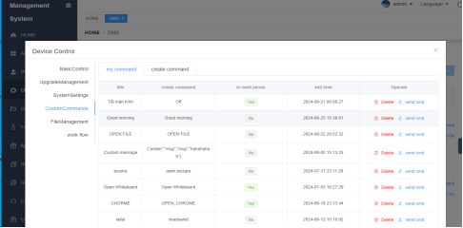

3.5 Equipment Control_File Management
Users can push videos, audios, pictures, and installation packages to designated devices in the background according to specific needs, and the device can receive the uploaded audio and video.

3.5.1 File Transfer
- video
Click "File Transfer", select "Video", and click the "Upload" button to select the video; after the upload is completed, a new column of video information will be added to the list, and the device will receive the video.
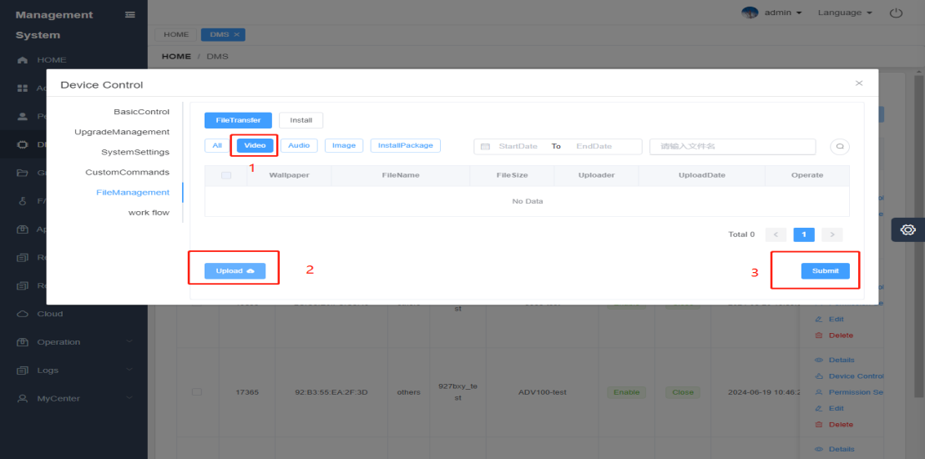

- Audio
Click "File Transfer", select "Audio", and click the "Upload" button to select the audio; after the upload is completed, a new column of audio information will be added to the list, and the device will receive the audio.
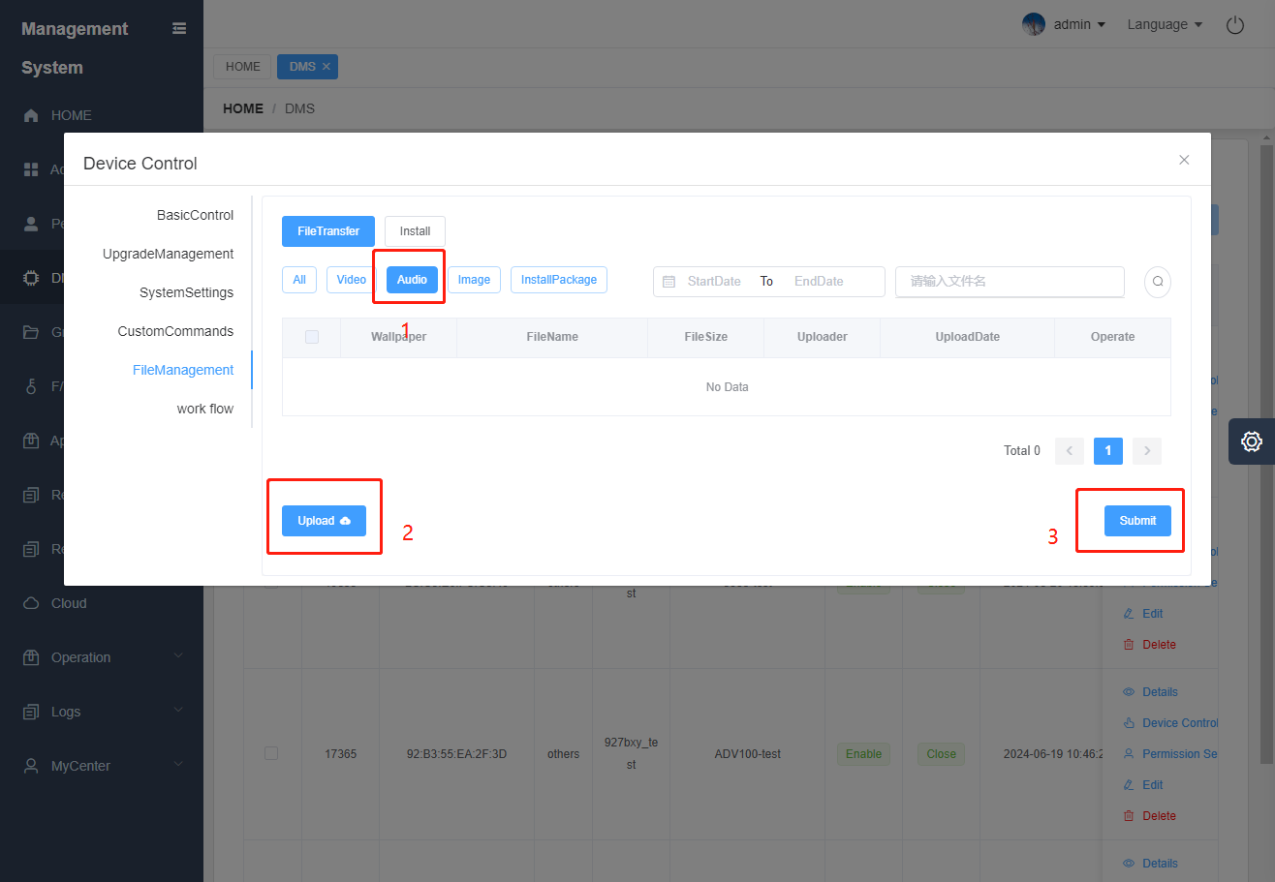

- picture
Click "File Transfer", select "Picture", and click the "Upload" button to select the picture; after the upload is completed, a new column of picture information will be added to the list, and the device will receive the picture.
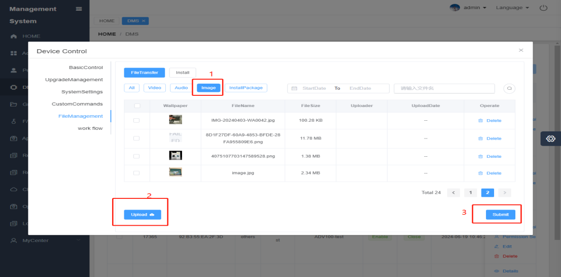

- Installing Packages
Click "File Transfer", select "Installation Package", and click the "Upload" button to select the installation package; after the upload is complete, a column of installation package information is added to the list, and the device receives the installation package
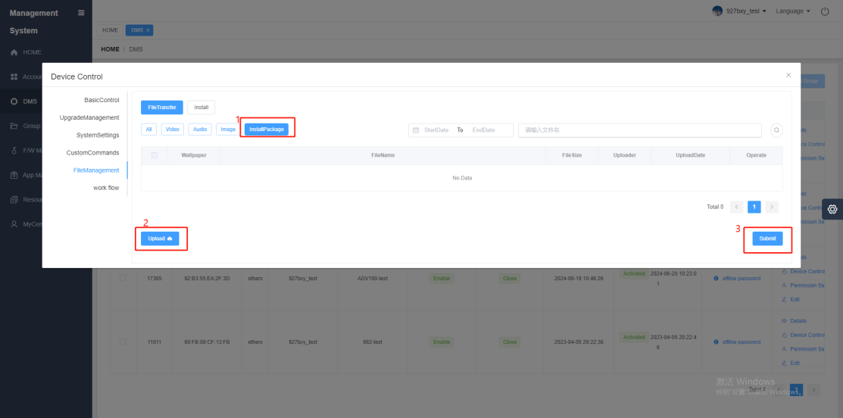

3.5.2 Installation
- Installing Packages
Click "Install", select "Installation Package", click the "Upload" button to select the installation package; after uploading, a column of installation package information will be added to the list
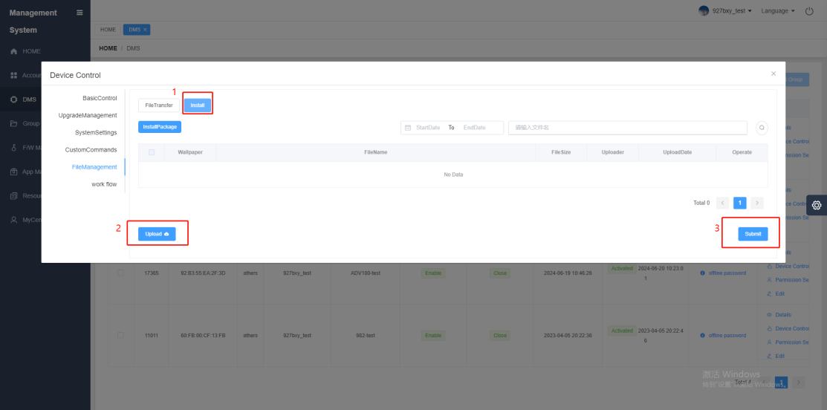

3.6 Equipment Control_Workflow
Workflow means organizing some commands and executing multiple commands in sequence (9 commands are available by default, including shutdown, restart, send alarm, message notification, lock, unlock, backlight, volume, signal source, etc.). The following are the steps of workflow:
- Added
Enter the workflow under the device control page, click "Add", enter the name and description, and click the "Submit" button.
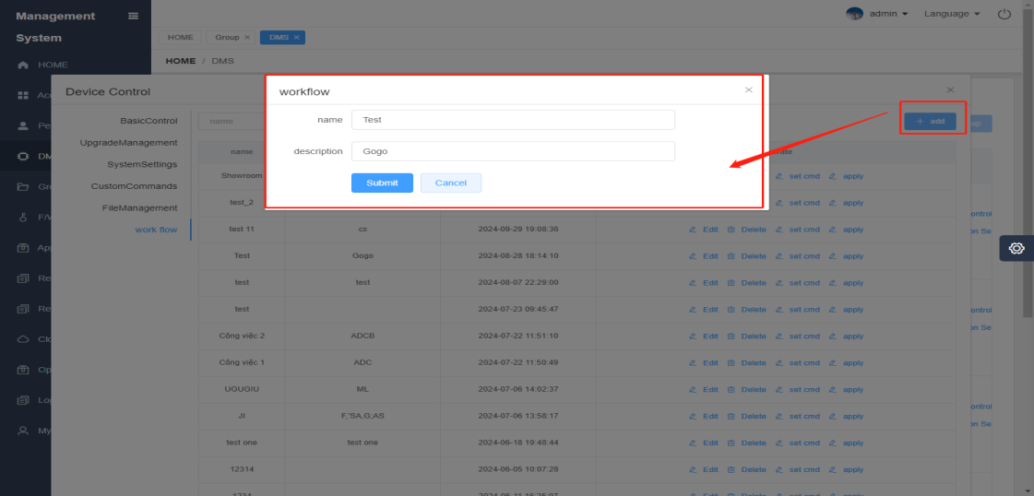

- edit
Select the workflow you want to modify, click "Edit", and reset the workflow information.
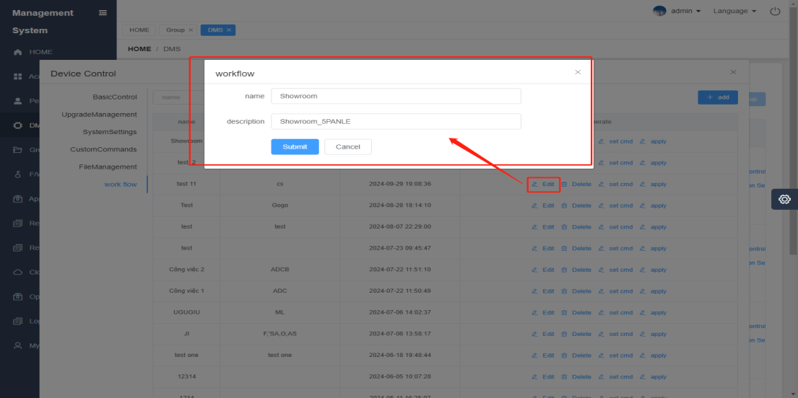

- delete
Select the workflow you want to delete and click "Delete" to delete the workflow.
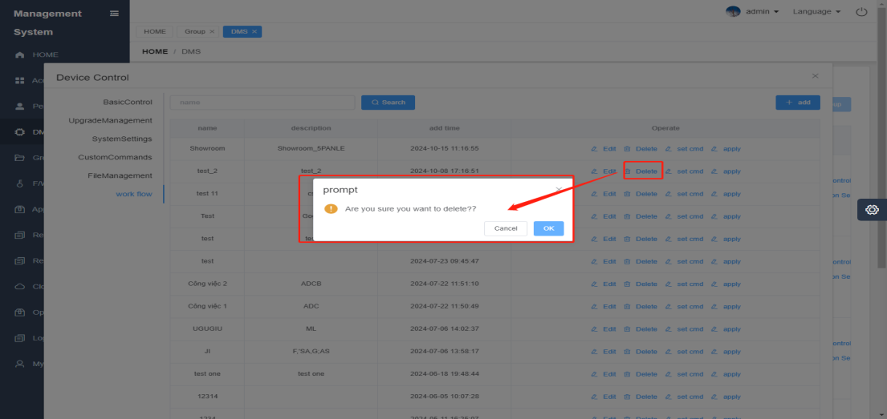

- Configuration directives
Select the workflow that needs to be configured, click "Configure Instructions", and a pop-up window will pop up as shown below;
Click ① "Add" to add a new command on the ② list page, and you can ③ "Delete" a single command, and click ④ "Close" to exit the command configuration.
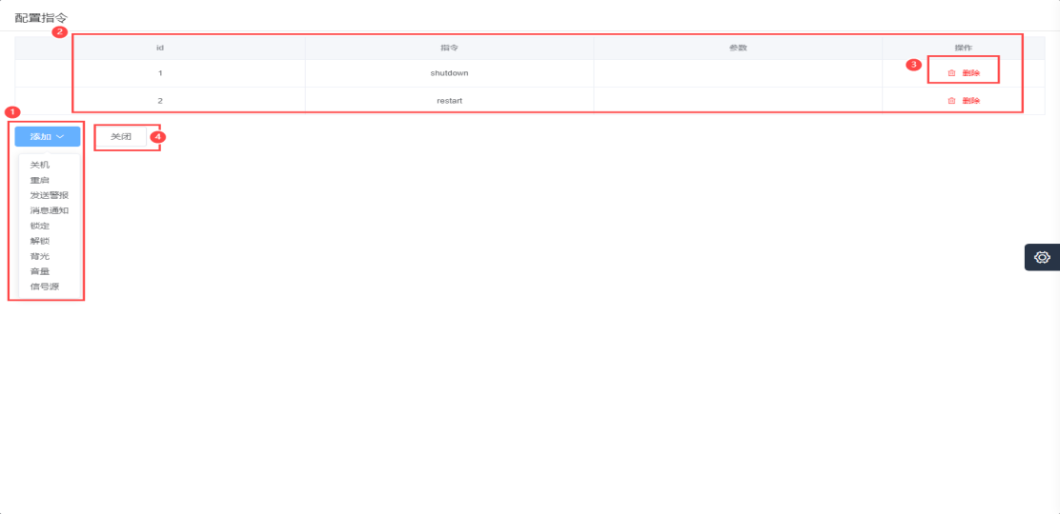

- application
After configuring, click "Apply" and the device will execute the instructions in the workflow in sequence.
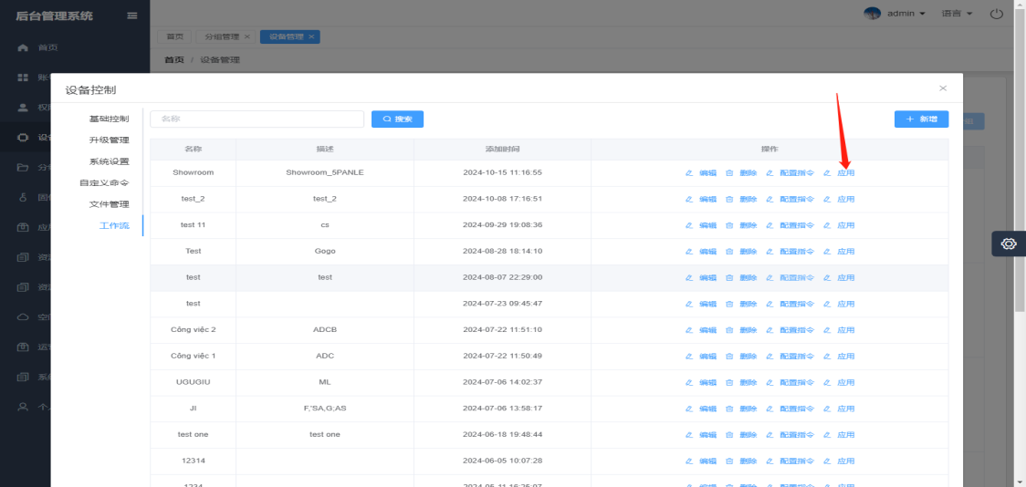

4. Operation

4.1 Operation_View details
Users can view device parameters and application statistics for devices, and Admin/OEM can view details of their devices
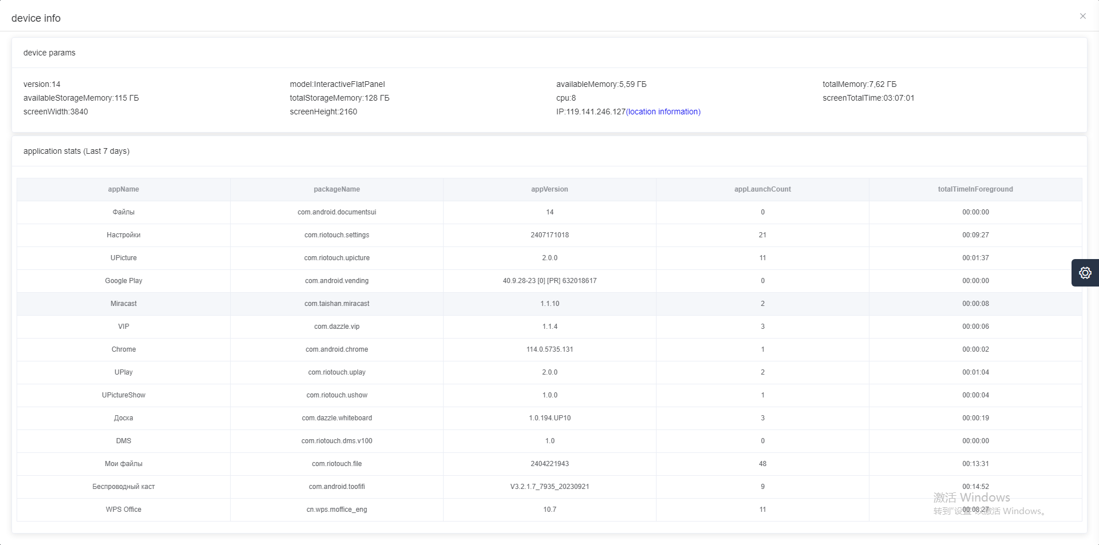

4.2 Operation_Permission Allocation
Assign device mac permissions to specified users;
OEM has the following device management permissions (add device, add group, set, view details, device control, permission allocation, edit), as shown in the figure
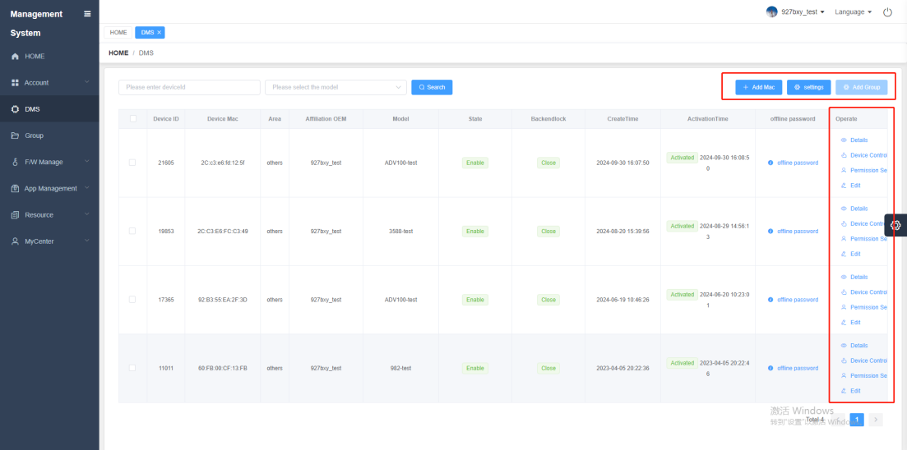

School has the following device management permissions (adding groups, device control, and permission allocation), as shown in the figure
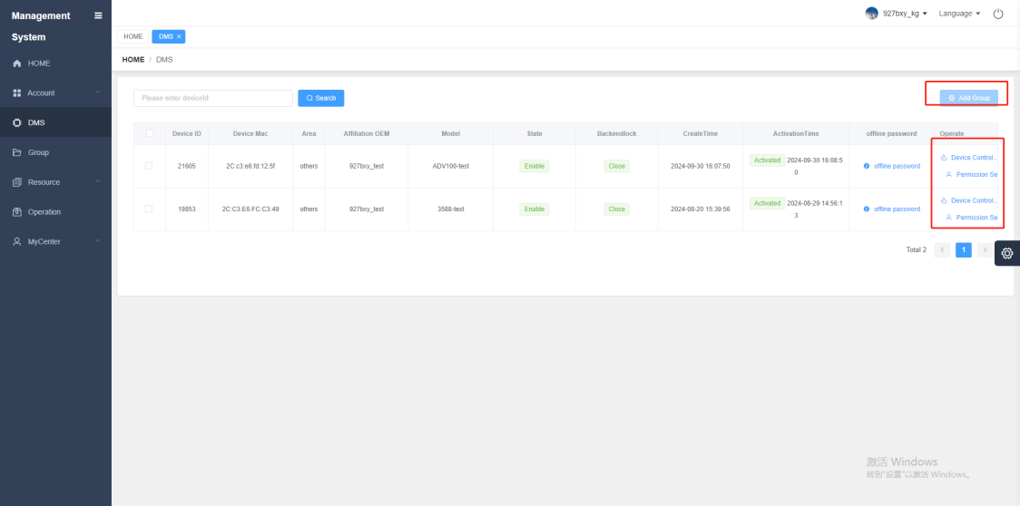

- Admin "Permission Allocation", as shown in the figure

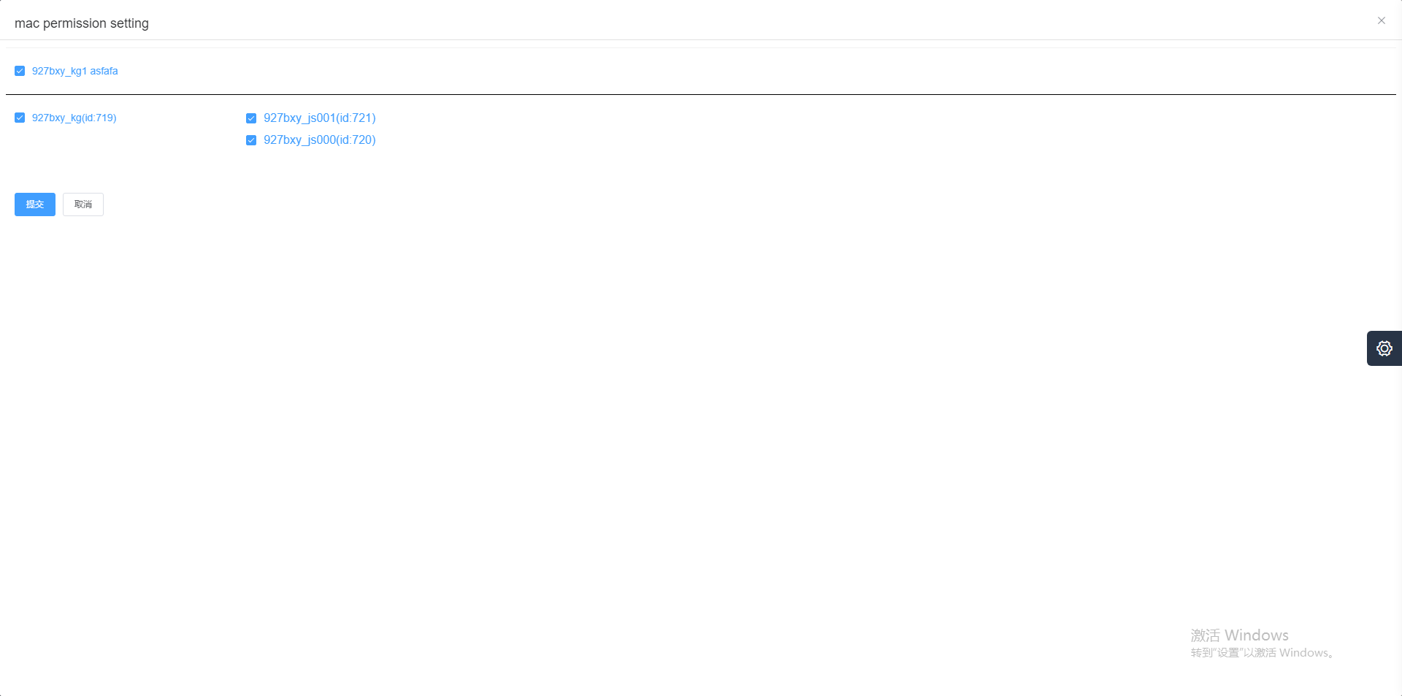

- OEM "Permission Allocation", as shown in the figure

4.3 Operation_Edit
Select the device and click "Edit" to modify the device information, such as binding the Mac to other OEM users
- Admin "Edit", as shown
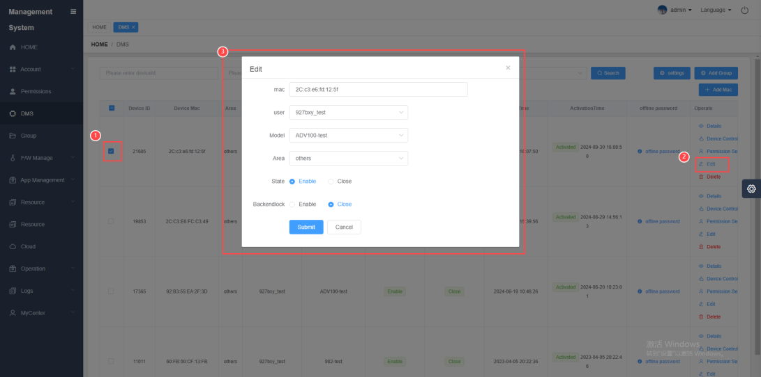

- OEM "Edit" as shown
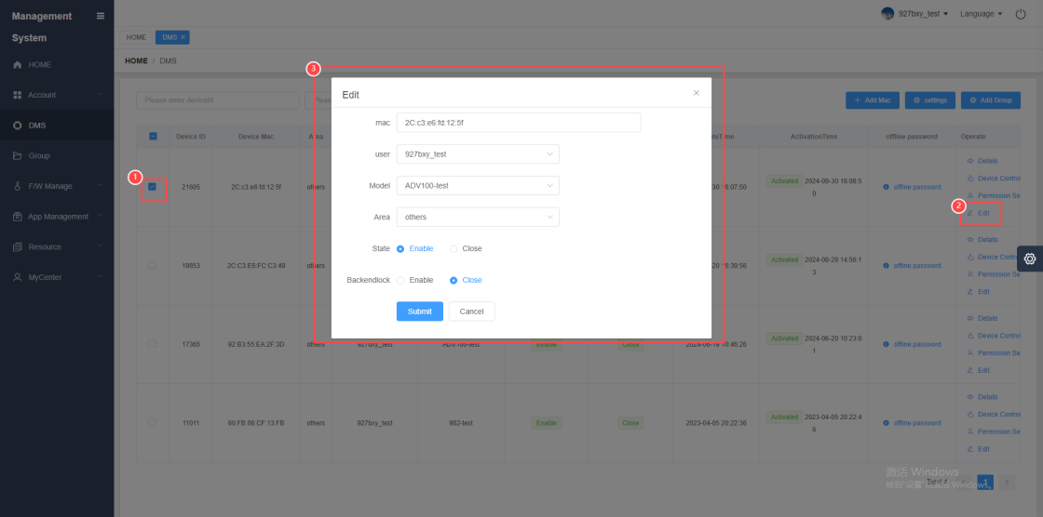

4.4 Operation_Delete
Select a device and click "Delete" to delete the device from the device list. Only Admin can perform the "Delete" operation.
- Admin "Delete", as shown in the figure
