- UI，can add themes.
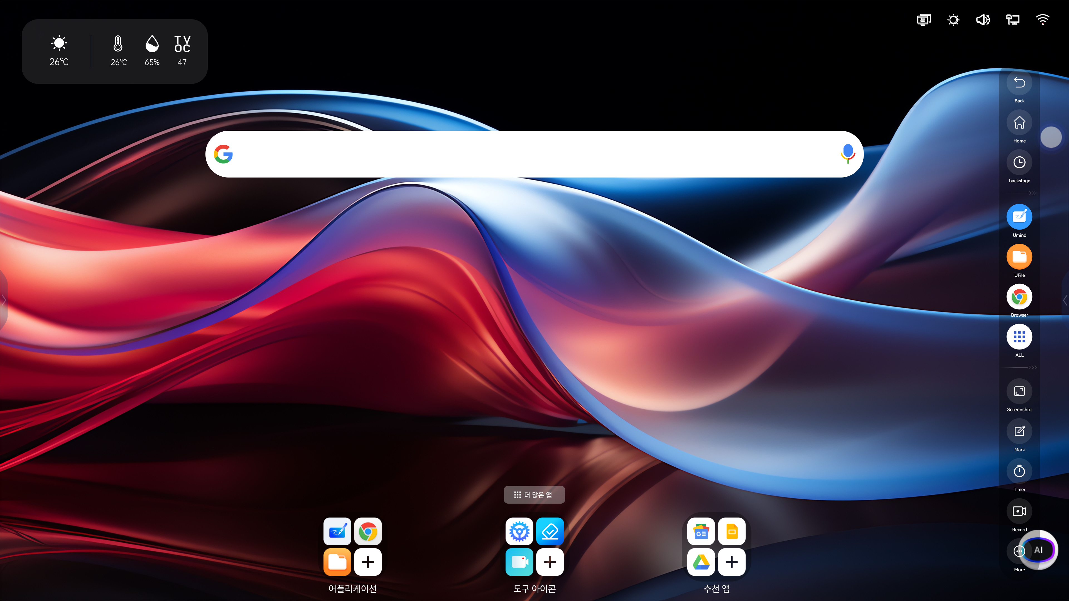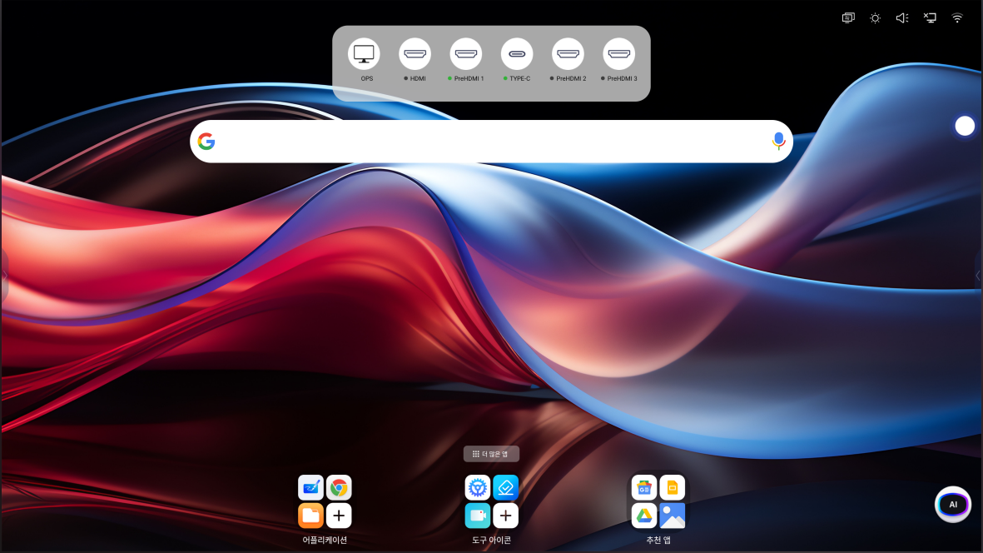
Green dot，Green circle，Ops determines input
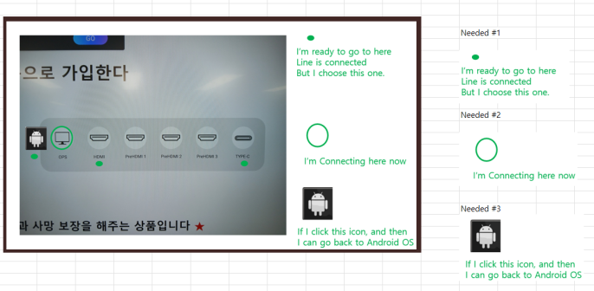
The screenshot function is in the floating ball menu
- The floating ball and sidebar menu can be closed by clicking anywhere
- After expanding More app，places all applications in the middle of the interface
- The Timer of the floating ball shortcut key and the multitasking button of the side button menu are swapped
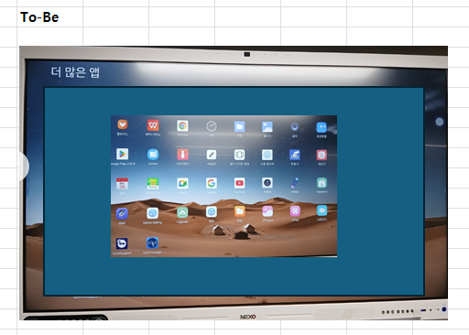

Customized:
- There are too few colors for desktop annotation pens. It is possible to make them in different colors and control the depth.
- Download APK from Ufile Remove password.
- The background colors of the Android whiteboard software are too few. hopes to have more colors. RGB color number
- Eraser pen tool touches other objects, acceleration library and rendering issues. When writing and erasing on the added screenshot window, it shows that the screenshot window is also deleted, but it is not actually erased. Customers need to solve this rendering bug, only display the erased handwriting, and the screenshot window remains unchanged; when customers want to annotate on a polyhedron such as a cylinder, the polyhedron will not be erased when the eraser is erased
- The native file manager will ask once when opening a file or always use this method. Ufile opens the file directly without asking. The customer wants to add this asking function.
- The color of our URecord annotation pen can be made the same as the pen in Umind. You can choose the color and depth.
- File opening type, default opening application can be reset in settings, in Android environment
- UmindSimplify Image Optimization
- There will be tips and a list of new features for any future software updates.
- PDF Annotation
- The latest versions of Ucut, Umind, URecord, and Eshare are pre-installed when shipped
- The whiteboard software of Windows version.

